



Machine Learning

Contents

Contents

What is Azure Machine Learning? 2

The Problem Domain 3

First Time Setup 4

Save the Dataset 9

Training the Model 11

Optimizing Classifiers 18

Creating a Scoring Experiment 24

Publish as a Web Service 30

Testing the Web Service 31

Publish to the Gallery 35

Conclusion 38

Optional Lab: Data Processing 39

Introduction

First Time Setup

The Data

Data Processing

Training the Model

Comparing Classifiers

Publish as a Web Service

Visualise Results

Conclusion

Extra Resources

# What is Azure Machine Learning?

This lab will introduce you to machine learning capabilities available in Microsoft Azure. Microsoft Azure Machine Learning (Azure ML) allows you to create basic designs and complete experimentation and evaluation tasks.

In this lab, we will cover Azure ML Studio, a fully managed machine learning platform that allows you to perform predictive analytics. Azure ML Studio is a user facing service that empowers both data scientists and domain specialists to build end-to-end solutions and significantly reduce the complexity of building predictive models. It provides an interactive and easy to use web-based interface with drag-and-drop authoring and a catalogue of modules that provide functionality for an end-to-end workflow.

In some scenarios a data scientist may not understand the domain data as thoroughly as a domain expert does. Microsoft Azure Machine Learning has made it possible for the people who know the most about the data to produce predictive analytics for that data.

# The Problem Domain

During this lab, you will create and publish a model that predicts if a flight will be delayed depending on a range of flight details and weather data. The two datasets used are flight delay data and weather data. These sets consist of records for flights and the weather at each airport on an hourly basis.

The columns of the flight delay dataset hold information such as the date and time of a flight, the carrier, origin and destination ID’s as well as delay time information.

The columns of the weather dataset hold information such as the Airport ID, date and time and various weather measures such as visibility and temperatures.

The model you will create is a form of supervised learning; we will use historical flight and weather data to predict if a future flight is delayed. This model will use a binary classification technique, is the flight delayed or not, and produce a web service you can query with new flights

# First Time Setup

Microsoft Azure Machine Learning offers an 8 hour anonymous trial, a free-tier service and a standard tier (for which you need an Azure subscription). In order to access the free workspace, go to <https://studio.azureml.net/> ,

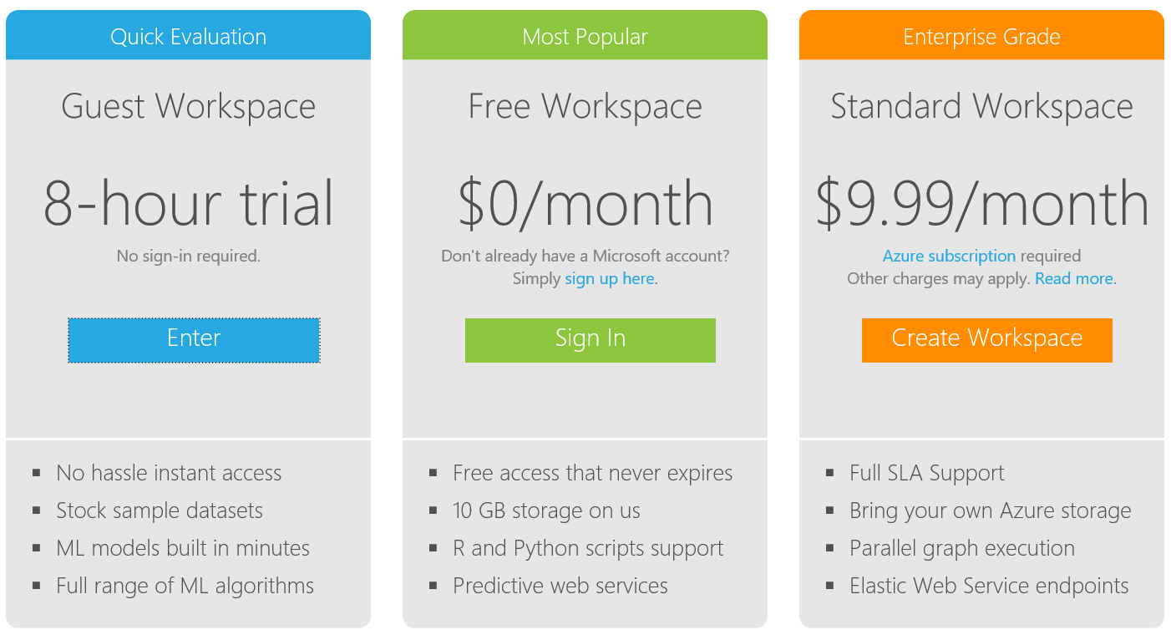

Select the Free workspace option and sign in with a Microsoft account (@hotmail.com, @outlook.com etc.) and a free workspace is automatically created for you.

If you don’t have a Microsoft account, create one here: <https://signup.live.com/signup.aspx>

Once on the Workspace homepage click on the link ‘Sign-in to ML Studio’ and you should land on an experiments page. From there find the ‘New’ button in the bottom left corner and choose ‘Experiment’ then ‘Blank Experiment’. Notice there are sample experiments you can also use, edit and build on top off.

The Data

Azure ML has a number of options for ingesting data from which we can build models to make predictions:

* Using saved datasets listed in the left hand modules menu
* Upload data files from your local machine. Azure ML accepts many formats including CSV, TSV, Plain Text and Zip files
* Alternatively, you can use the ‘Import Data’ Module to access your data from sources such as SQL Azure, Blob storage, HD insight and industry standard OData feeds.

However because this version of the lab is designed in just a morning we are going to use a specially designed experiment in which the data loading, cleansing and preparation has already been done. The instructor will quickly describe the mechanics and modules needed to do this and walk you through the steps in this experiment. If you wish to do this yourselves after the lab there is a section at the end of this guide, Optional Lab Data Processing.

Navigate to the sample experiment in the Cortana Intelligence Gallery, <https://gallery.cortanaintelligence.com/Experiment/Predicting-Flight-Delay-Demo-Experiment-Preprocessing-Stage-2> in the browser of your choice.

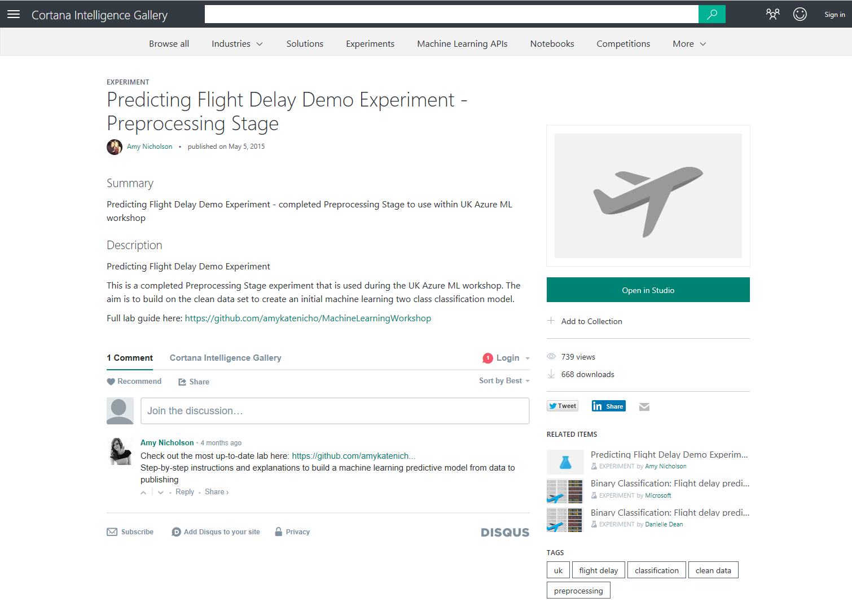

Click on Open in studio to save a copy into your workspace, you’ll be asked to confirm which one, and then it will open in the Azure Machine Learning studio (ML Studio)..

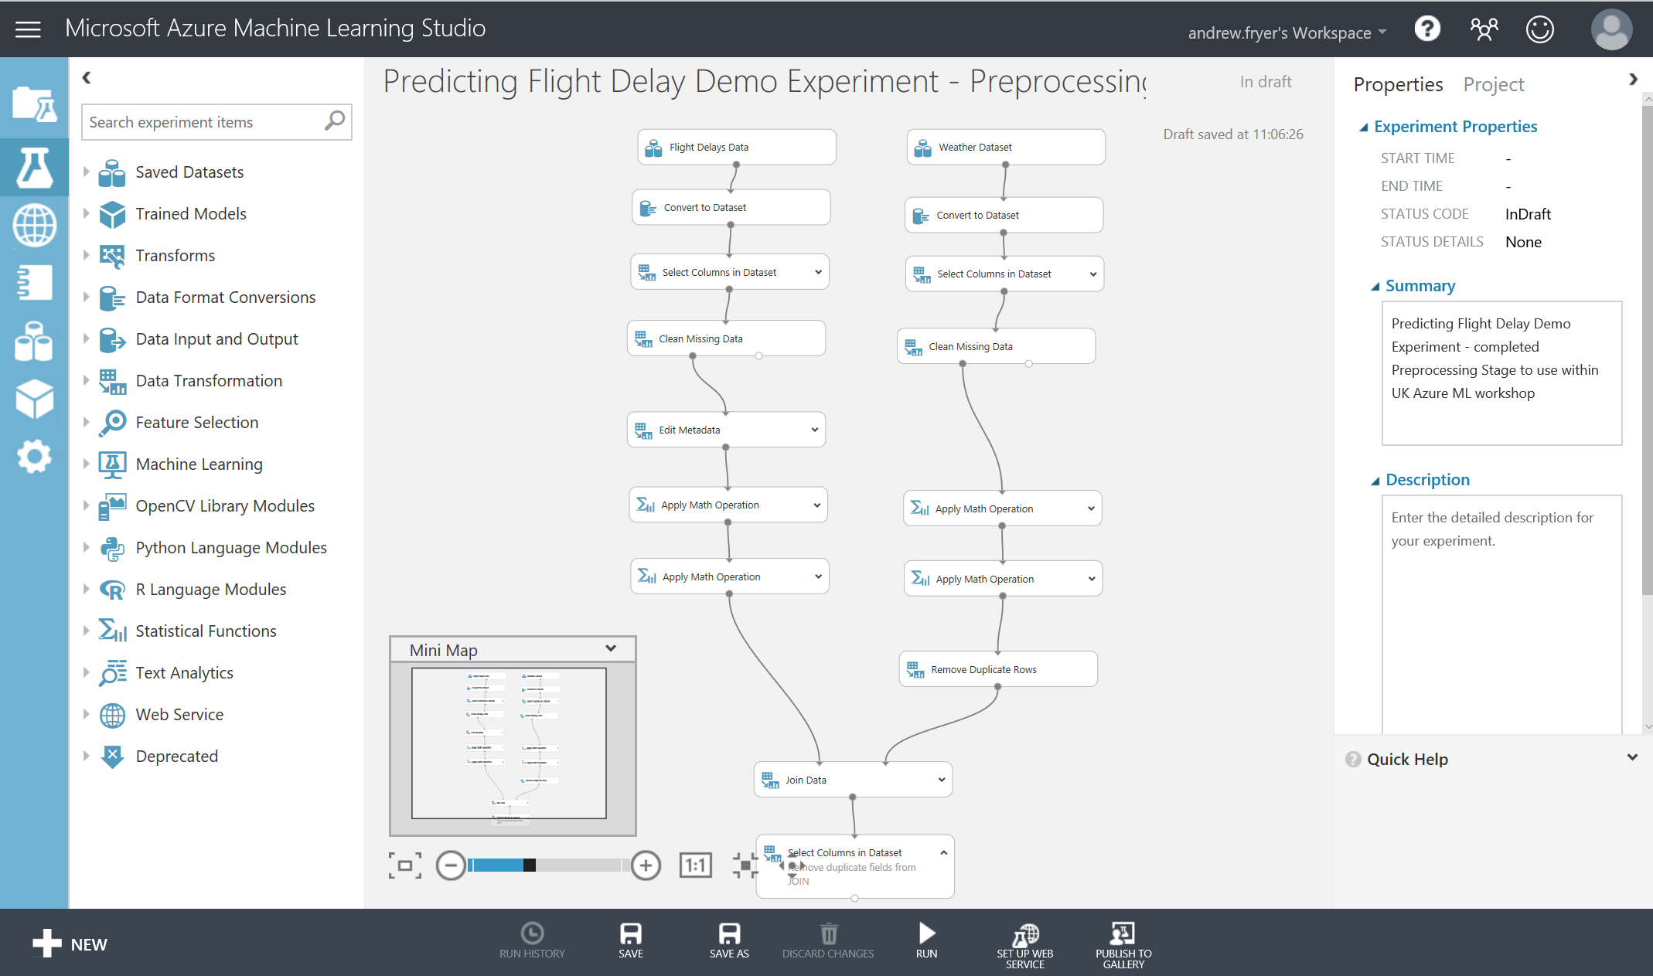

On the left in blue with white icons are the different objects we use in ML studio such as projects, Experiments, Web services, Jupyter Notebooks, Data Sets, Trained Models and Settings. Next on the left is a nested list of all the modules we can drag on to the design surface in the middle of the screen. On the right are the properties of the module that has focused or the whole experiment if no module is selected.

There are also functions we can perform in the bottom dark grey toolbar and the first thing we need to do is to click on Run to run the experiment as is.

The sample experiment has a column for each of the datasets we are working with, the flights and the weather with modules to clean transform these:

* Convert to Dataset ensures that the columns are correctly typed as numeric
* Select Columns in data set. We don’t need all the columns e.g. the weather data has column s for centigrade and equivalent Fahrenheit so we’ll just use the centigrade ones.
* Cleaning missing data removes rows with partial data – We have some 2.9 million rows of data and we are using this sample to build a predictive model and because we have a good selection of data we can simply remove any rows that have missing data for the columns we are interested in.
* Maths operations. We need to join the two sets of data together and while aircraft land all of the time, weather readings are only taken hourly (at 56 minutes to the hour). So these operations take the departure time of the flight and round it to the nearest hour and the same is done for the weather reading time.

If we right click on the small circle at the bottom of the Combined Flight and Weather Dataset module and choose ‘Visualise’

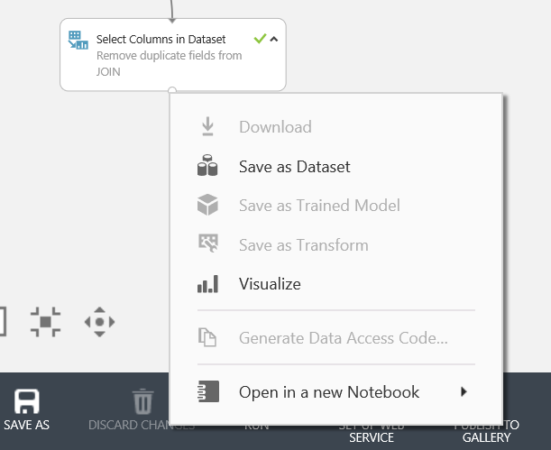

we can quickly see the data we are working with. This view shows you the first few rows of the dataset and various statistics about each column in the dataset, and here we can see a sample of the data and highlight any column to see basic statistics about that column e.g. Dry Bulb Celsius:

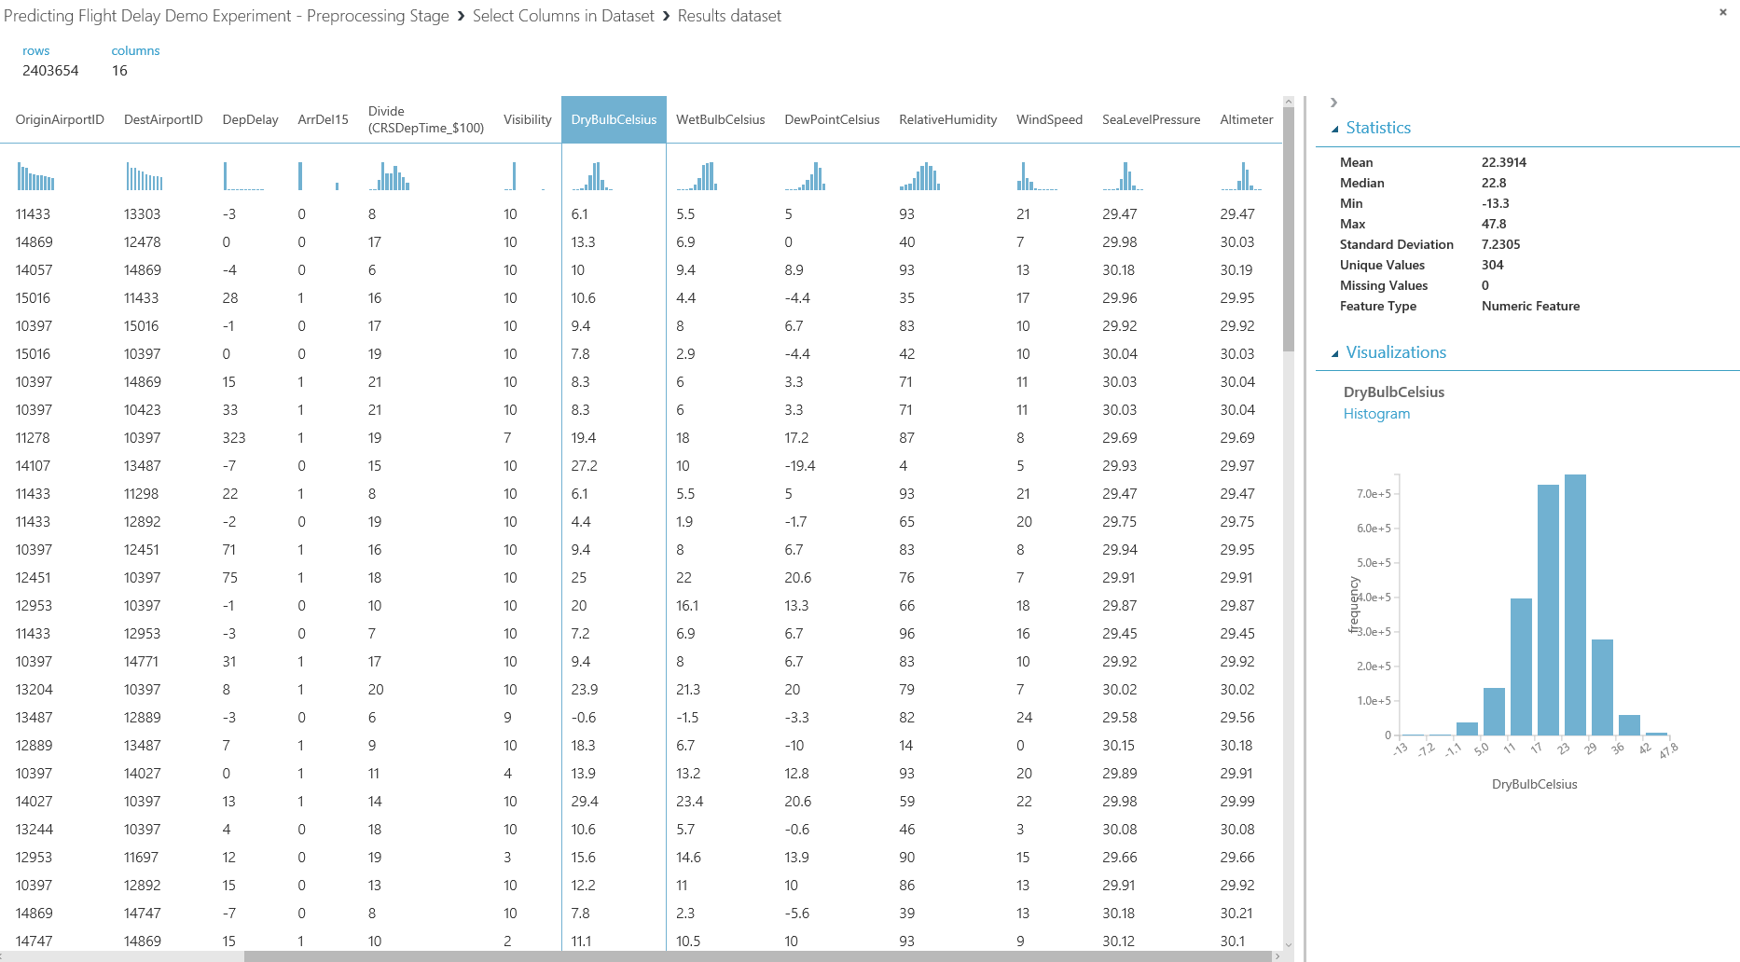

We can also use built on modules in ML Studio to get more insight about the data or use the built in Jupyter notebooks facility in ML studio to carry out our own interactive analysis in Python or R. There is an optional section in the guide for this at the end of this document.

There is one change we need to make to this experiment and that is to rename the odd sounding column. Divide (CRSDeptime_$100) to something more meaningful. To do this we’ll add an Edit metadata module to our experiment.

In the search box type metadata to find the edit metadata module:

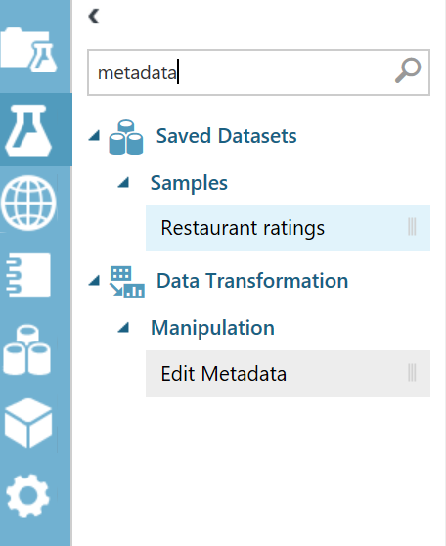

Drag it onto the experiment at the end as shown:

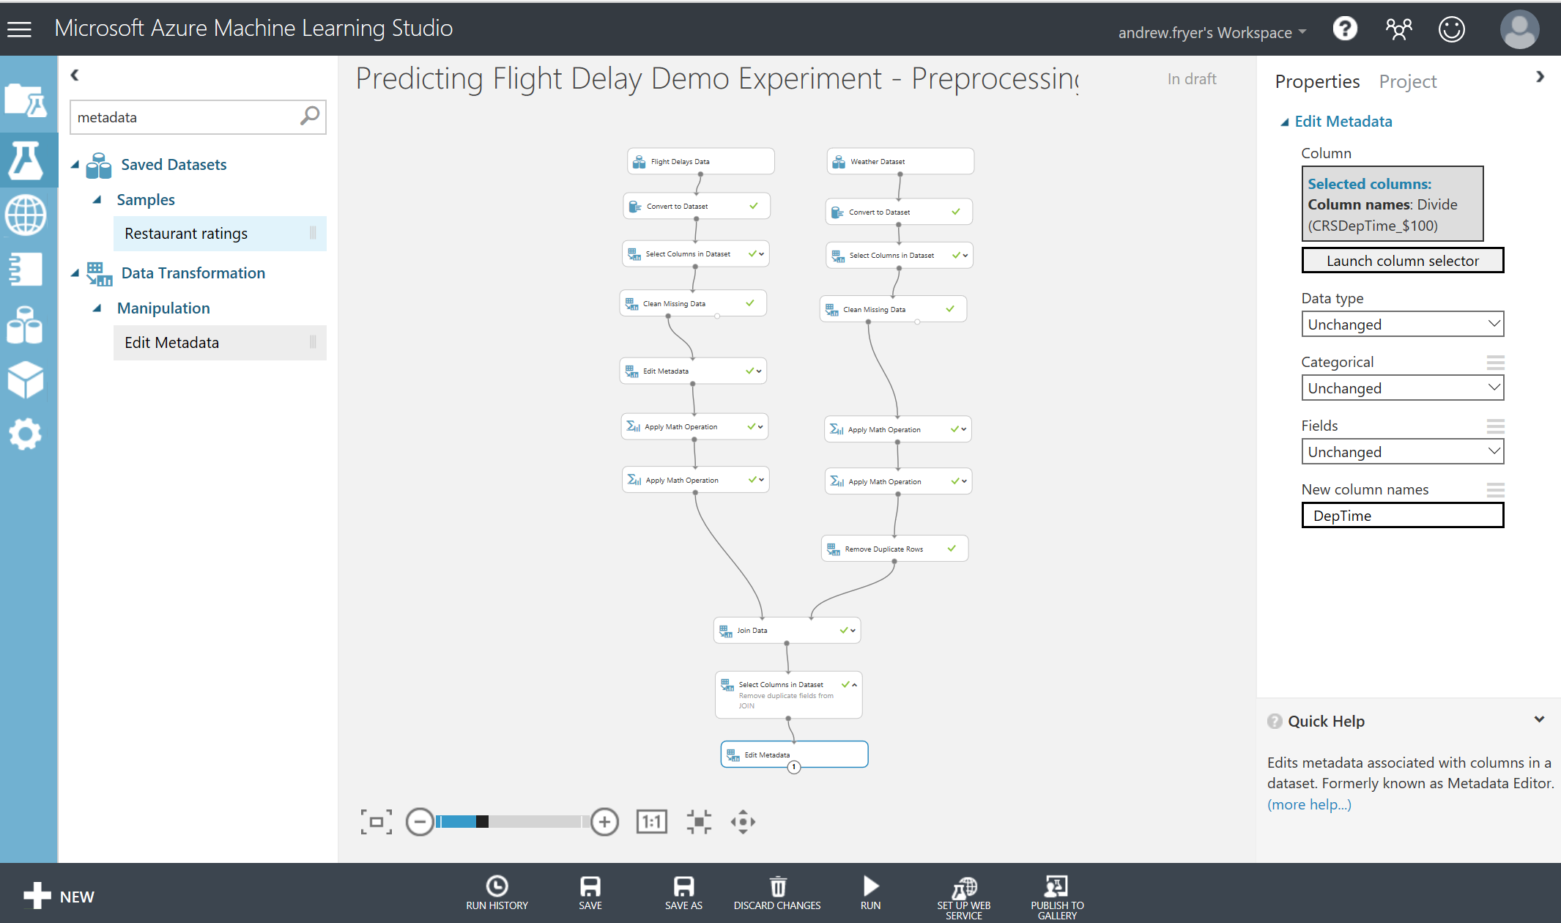

Drag a line from the output of the Select Columns in Dataset module to the input of the Edit module to connect the data flow. Edit the properties of the edit metadata:

* Launch the column selector an choose the Divide(CRSDepTime_$100):

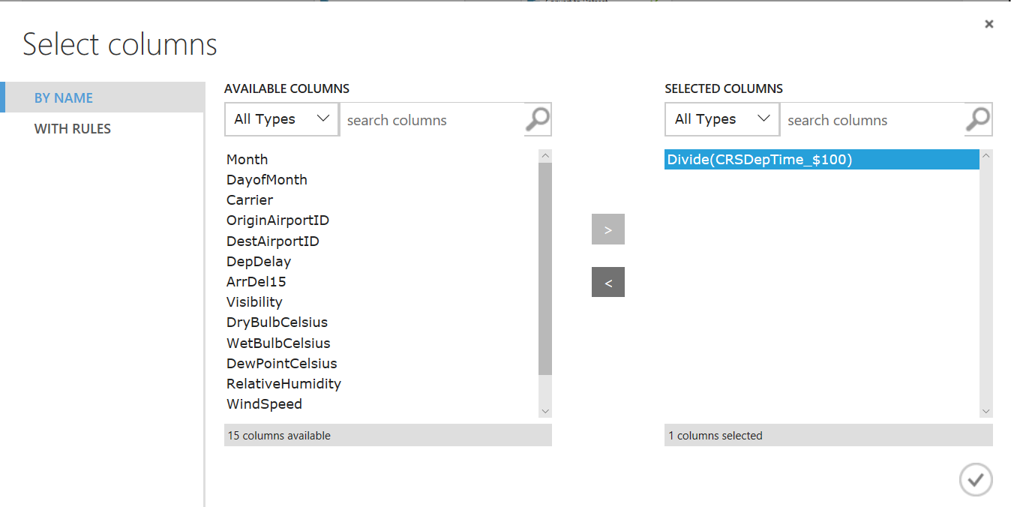

Click the tick box to save your selection and close this window

* Set the new column names property to DepTime

Right click on the edit metadata module and select Run Selected

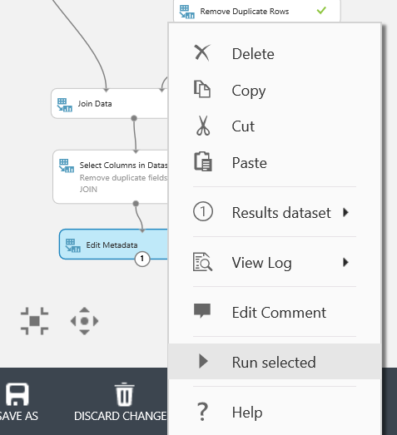

to just run this module and then visualise the output to check the column has been renamed:

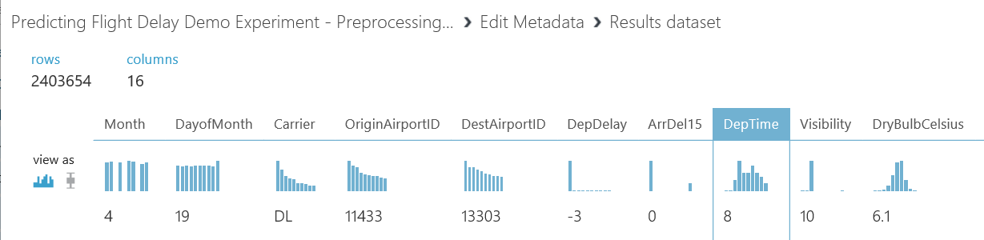

# Save the Dataset

At this point in the experimentation process we have a set of data than we can begin to use to build a model. So far we have used the various data wrangling tools in ML to do this, and while that is a useful introduction to ML Studio in a real world scenario we would probably do something different. Typically, we would do this sort of pre-processing in another tool before loading it into ML using tools like SQL Server Integration Services, Azure Data Factory, Informatica etc. and so our starting point would be the dataset we have now created. To simulate this, we’ll save the dataset in the shape we have now by right clicking on the last module and selecting Save as Dataset.

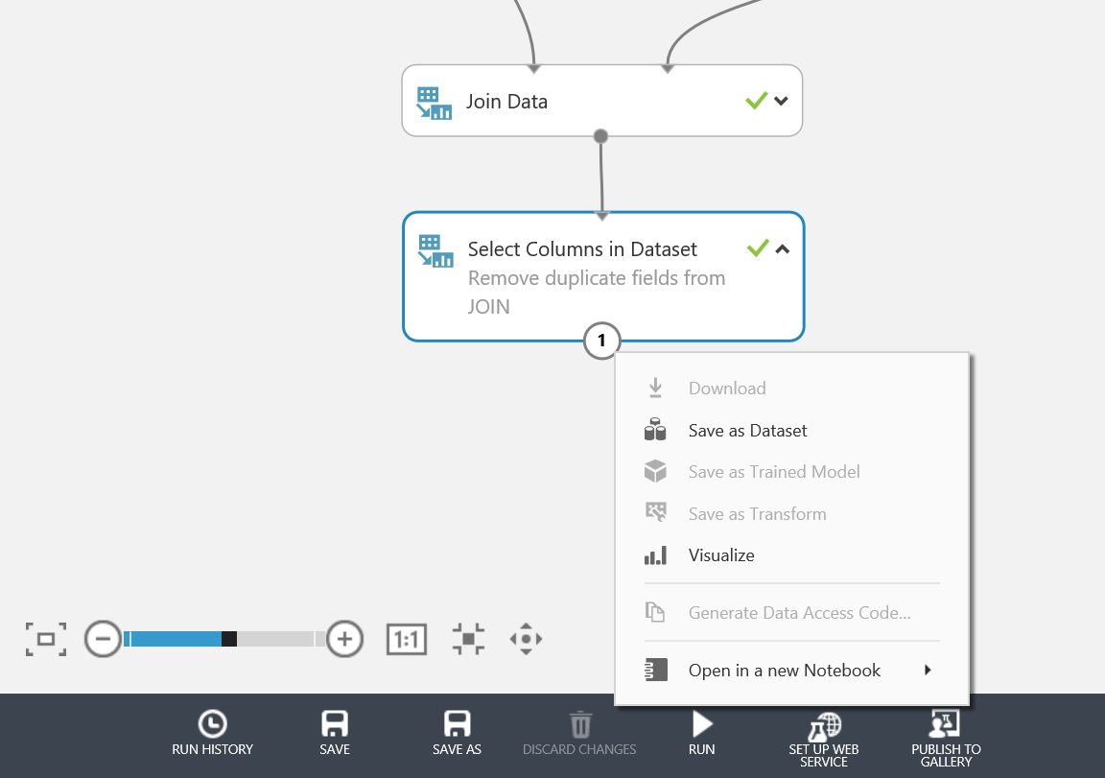

Give the data set a name like Flight Delay Data and save it.

We can now create a new blank experiment and drag this new dataset onto the design surface. To find the save data set expand Saved Datasets -> My Datasets.

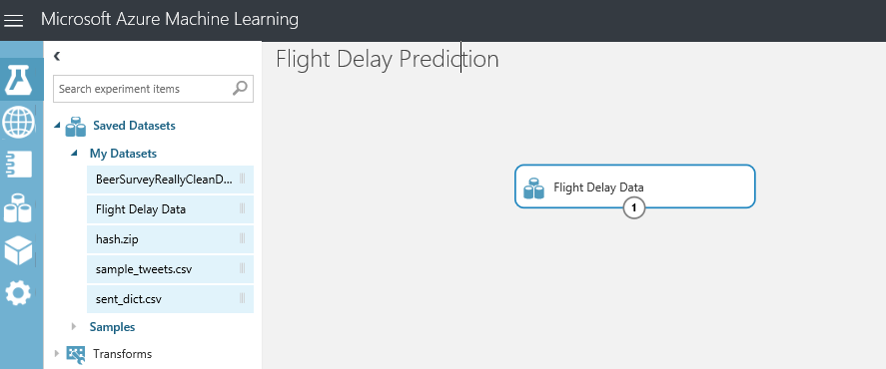

# Training the Model

At this point in the experimentation process we have a clean set of data that can be used to train and evaluate a model. We are moving from the business knowledge domain to the machine learning domain. To predict if a flight is delayed or not based on historical data sets, this experiment is a form of supervised learning and we will apply binary classification models to the data to predict if a flight is delayed or not.

*Check out the ‘Key Word Definitions’ section at the bottom of this document for machine learning term explanations*

Within machine learning we say that the data is a feature or a label. A label in the dataset is a column that tells us the ‘known truth’ for that data entry. This is the column we pass to our algorithms and say, learn from the historical data the patterns present that mean this label is correct. The other data in the set to be learnt from, are called feature columns. Some features will be more impactful than others, however we will see this later.

In order for Azure ML to understand what the labels and features are in our dataset, we must tell it using the Metadata Editor module. Connect the ‘Edit metadata’ module to the ‘Select Columns in Dataset’ or ‘Flight Delay Data ‘ output port, select the ArrDel15 column and remember to click the tick to save the selection.

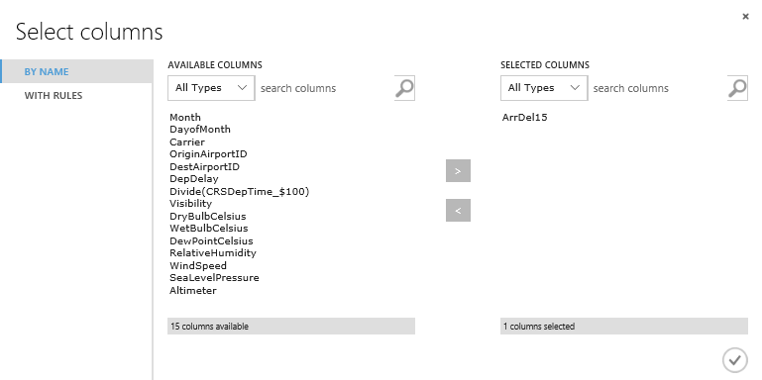

In this lab we want the classifier to learn the behaviour of ‘ArrDelay15’ therefore in the ‘Fields’ parameter select ‘Label’.

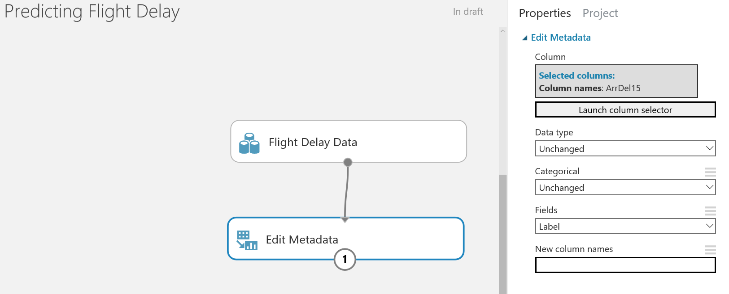

Finally, we need to tell Azure ML that the rest of the columns in the set are features and it should find patterns in this data that effect the ArrDel15 column. Drag another ‘Edit Metadata’ module onto the design surface and edit its properties as follows. In the Select columns dialog select “WITH RULES”, Begin with all columns and ‘Exclude’ all labels. Set the Fields property of the ‘Edit Metadata’ module to ‘Features’.

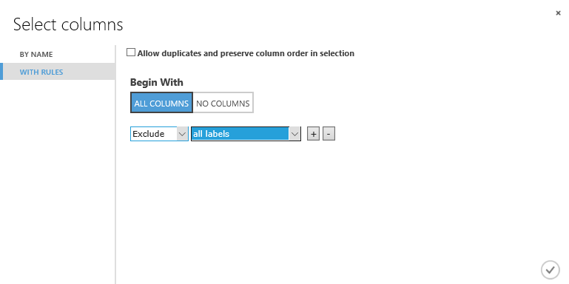

Next we will split the data into two sets; training and test data. The sets will have an 80:20 split respectively. The data is split into two parts so that some data is used for training, and some used to validate the trained model when scoring. We’ll also want to stratify the split over the label to ensure that each of these separate groups of data have the same ration of values in the label i.e. the train score and evaluate sets of data will have the same ratio of on time to delayed flights.

Drag and drop the first split module onto the workspace. Connect this to the project columns module and set the ‘fraction of rows in the first output dataset’ field to 0.8 (80%). Set the “Stratified Split” option to True and set the stratification key column to all labels.

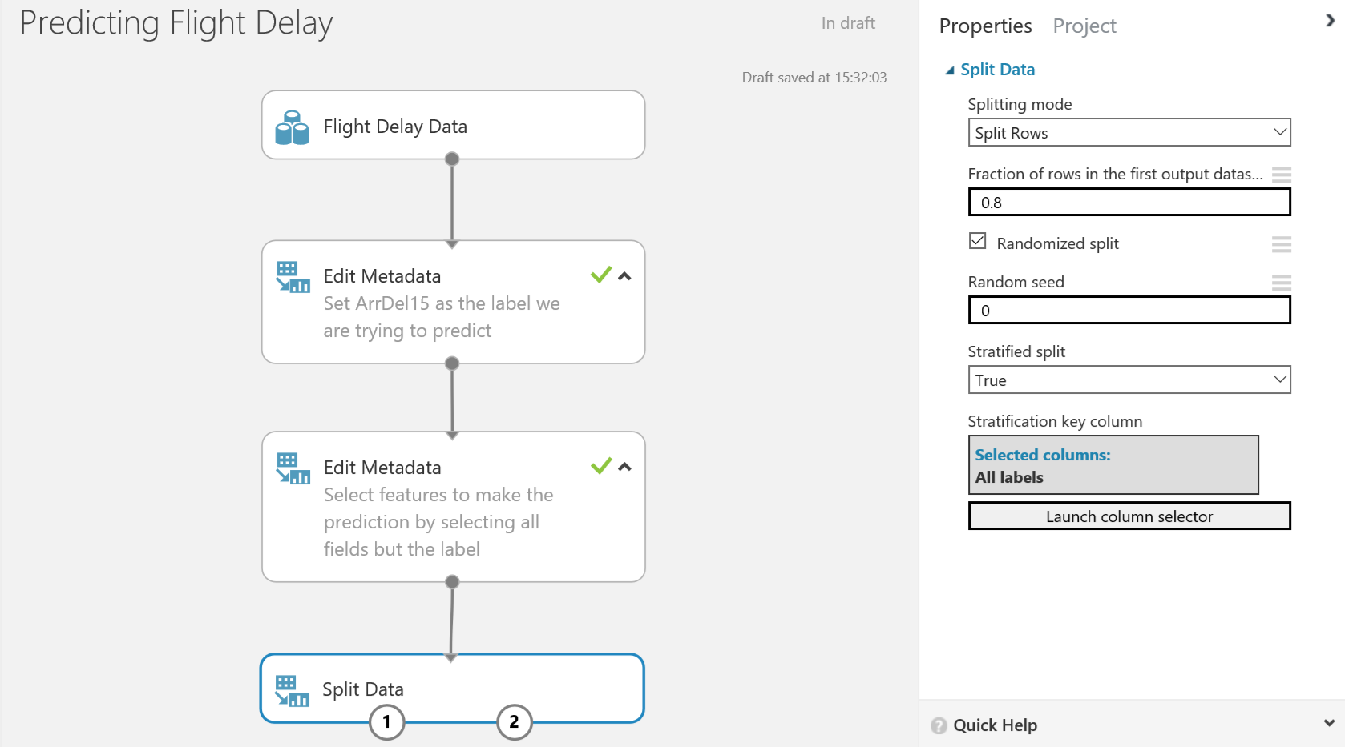

After splitting the data, choose a classifier from the module list in the left hand menu. There are many classifiers depending on your prediction problem and the type of learning you want to use. In the accompanying deck with this lab there is a cheat sheet on which algorithm to use. For this lab we will use the ‘Two-Class Logistic Regression’ classifier module. Drag and drop this onto the workspace.

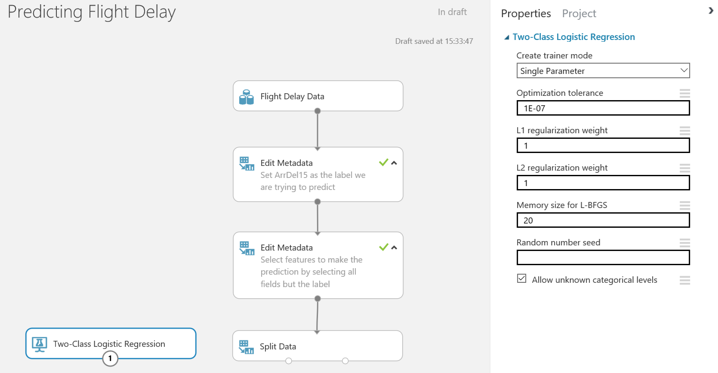

Next, drag and drop a ‘Train Model’ module onto the workspace. Connect the classifier to the left input port and connect the training data to the right input port.

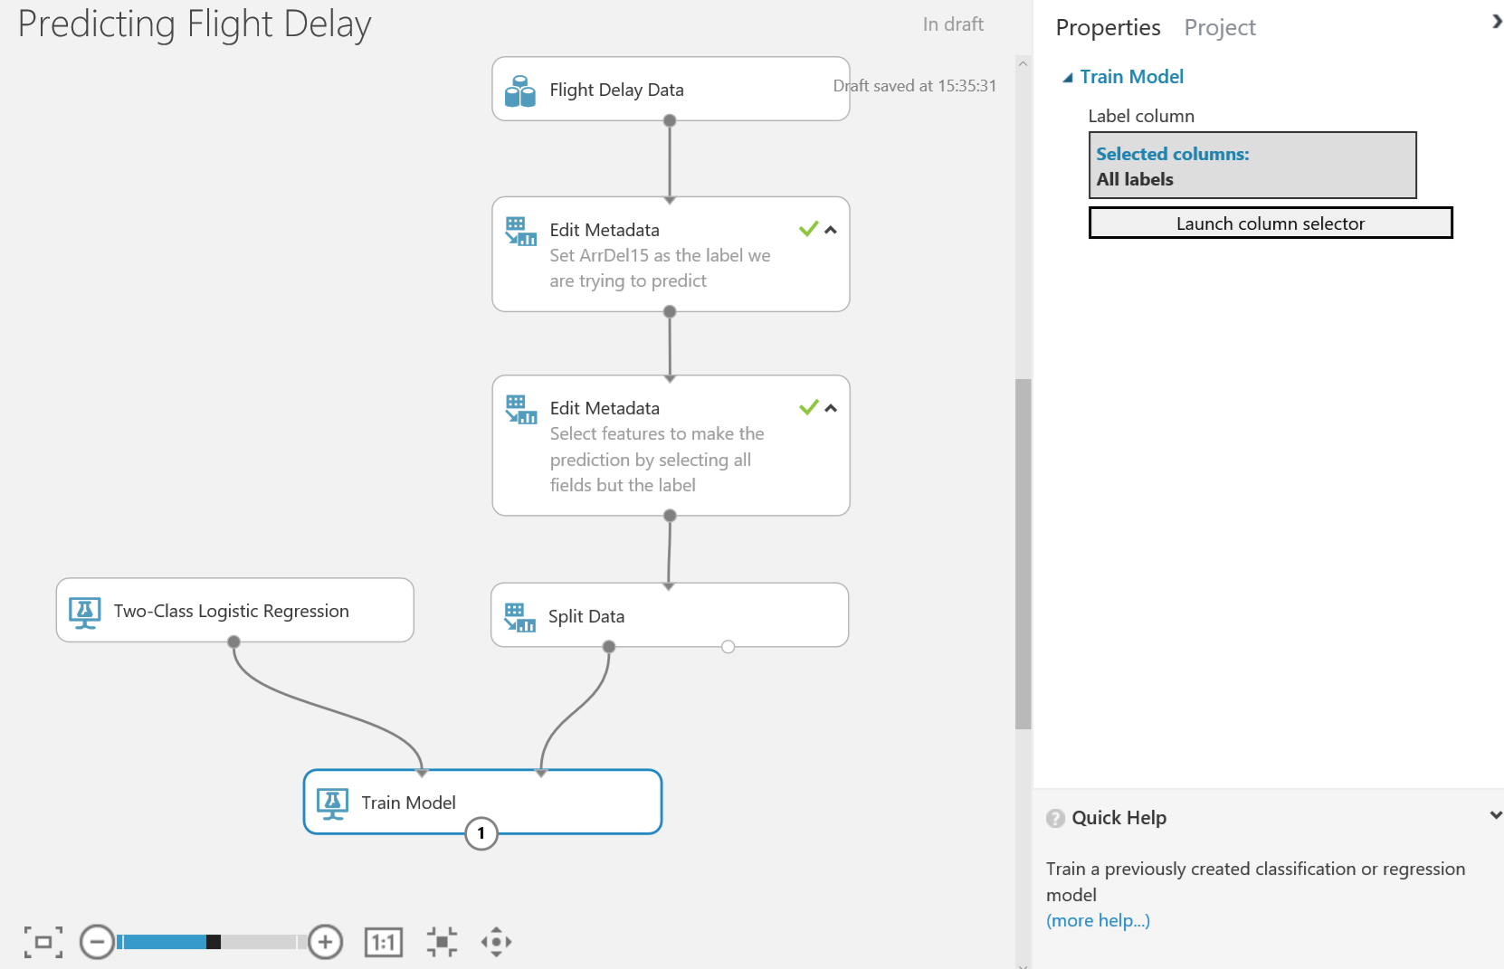

Select the Train module and look at the properties menu. Click on the ‘Launch Column Selector’ module and you can choose the column you want to learn (our label) by selecting ‘Include’ and the next drop down ‘All Labels’

Next use a ‘Score Model’ module to score the trained classifier against the test data. There are no parameters to set for the score module.

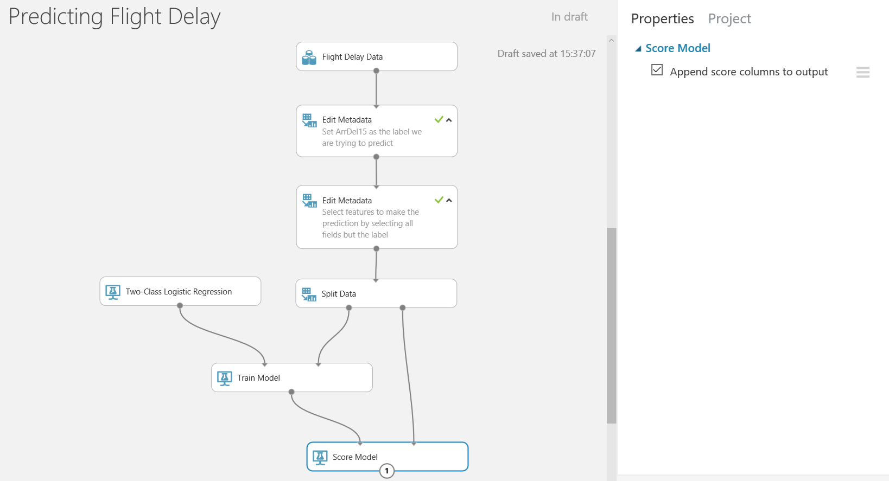

Using the ‘Evaluate Model’ module will evaluate the performance of the trained classifier on the test dataset. By using the test dataset you are providing the trained classifier with previously unseen data and asking it to classify it correctly based on what the classifier has learnt.

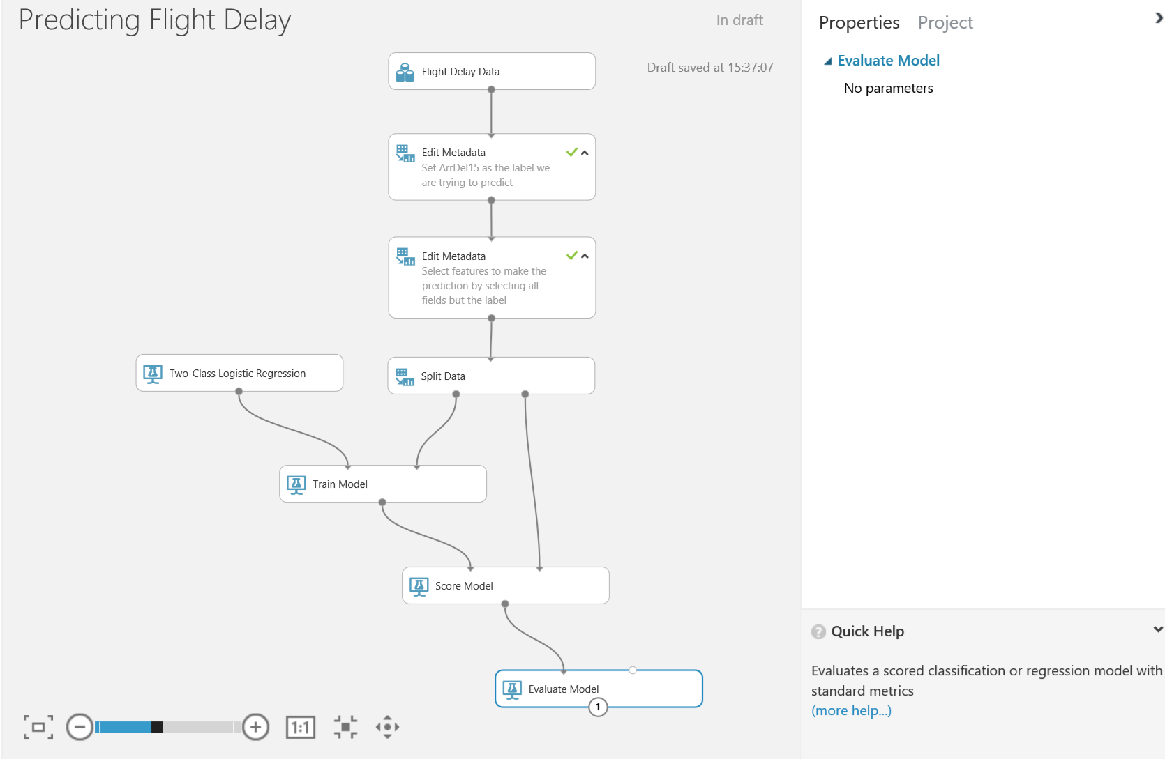

This produces visualisations including ROC curves and accuracy, precision, recall metrics etc.

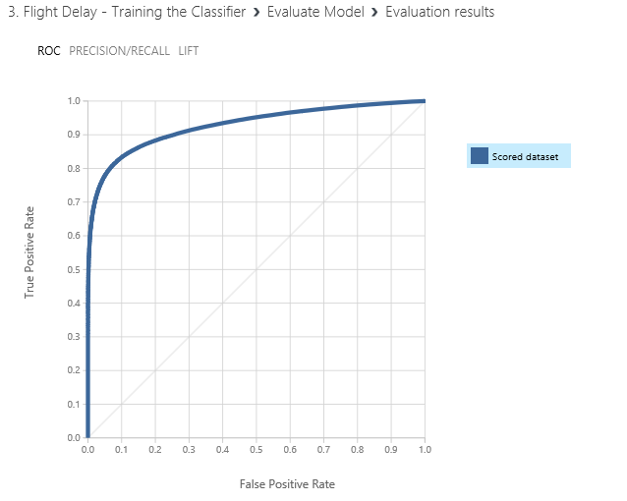

We also get a positive matrix of scores at the bottom of the screen

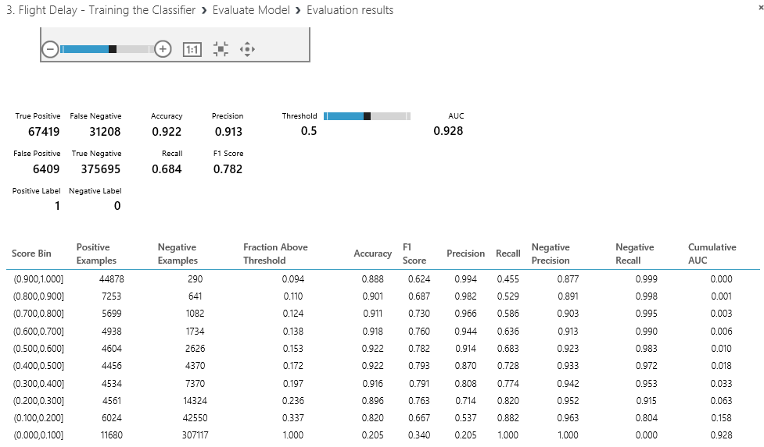

Where

**Accuracy** = True Positives + True negatives over the overall total = 0.922

**Recall** = true positives divided by true positives + false negatives = 0.684

**Precision** = true positives divided by true positives + false positives = 0.913

**F1 score** = .2 * (precision* recall)/ (precision + recall) = 0.782

This matrix is based on the threshold slider to the right of the matrix and defaults to 0.5 and sliding this will affect the numbers in the matrix.

# Optimizing Classifiers

Currently we have one classifier and its evaluation metrics. A great feature of Azure ML studio is that you can very easily compare multiple classifiers.

In this section we will compare the Logistic Regression classifier against the Boosted Decision Tree classifier to see which one best suits the data for our prediction.

Find the ‘Two-Class Boosted Decision Tree’ classifier and drag this onto the workspace. Notice in the properties pane there are many parameters you can set for each classifier. It is hard to optimise parameters manually, we will see later on in the lab how to optimise the parameters.

To speed things up lasso the train and score modules copy and paste them back onto the design surface and wire them up as shown below.

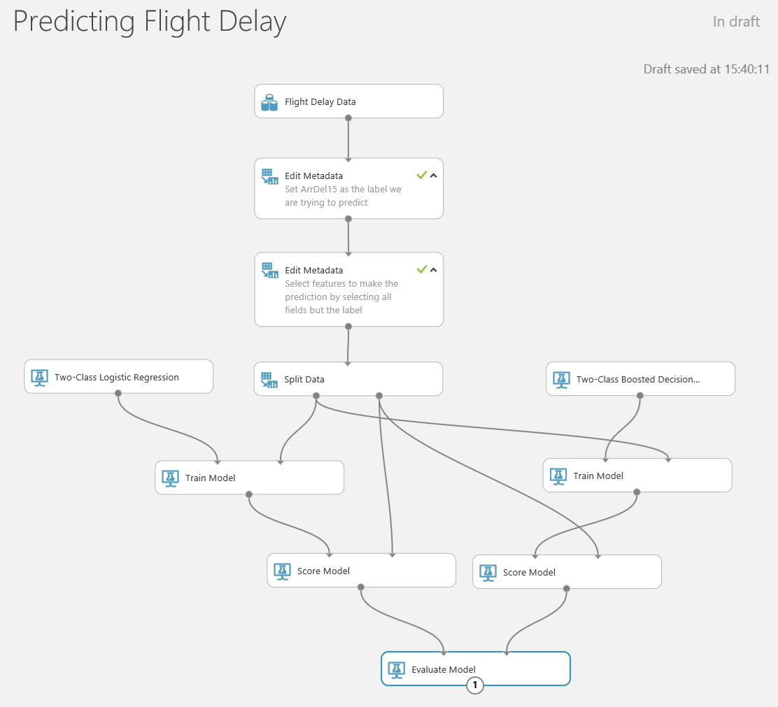

Note we can’t easily get this wrong as the modules only allow certain inputs to each port which show up red and green to guide us. The exception is the Evaluation module, it just worked with only one port connected but accepts two inputs from any scored model.

Run the experiment and select Visualize from the evaluation module to see how the two algorithms compare. The blue line is the left hand input, in our case logistic regression, and the red line is the new boosted decision tree (the right hand input).

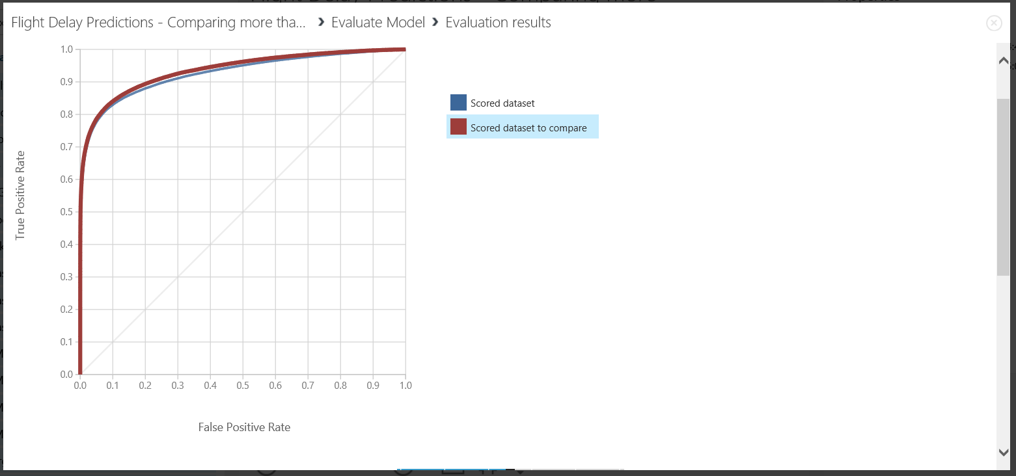

The results matrix is underneath the curve is for the curve we have selected.

Another interesting feature in Microsoft Azure Machine Learning is the ‘Filter Based Feature Selection’ module. This module allows you to select a set of all features; using a selected heuristic; to use in model construction. Now search for the feature selection module and drag it onto the workspace. This module will fit in just before we split the data to then train the various models.

Set the parameters as shown below:

* **Feature Scoring Method:** Chi Squared
* **Target Column:** ‘Include’ -> ‘All Labels’
* **Number of Desired Features:** 7

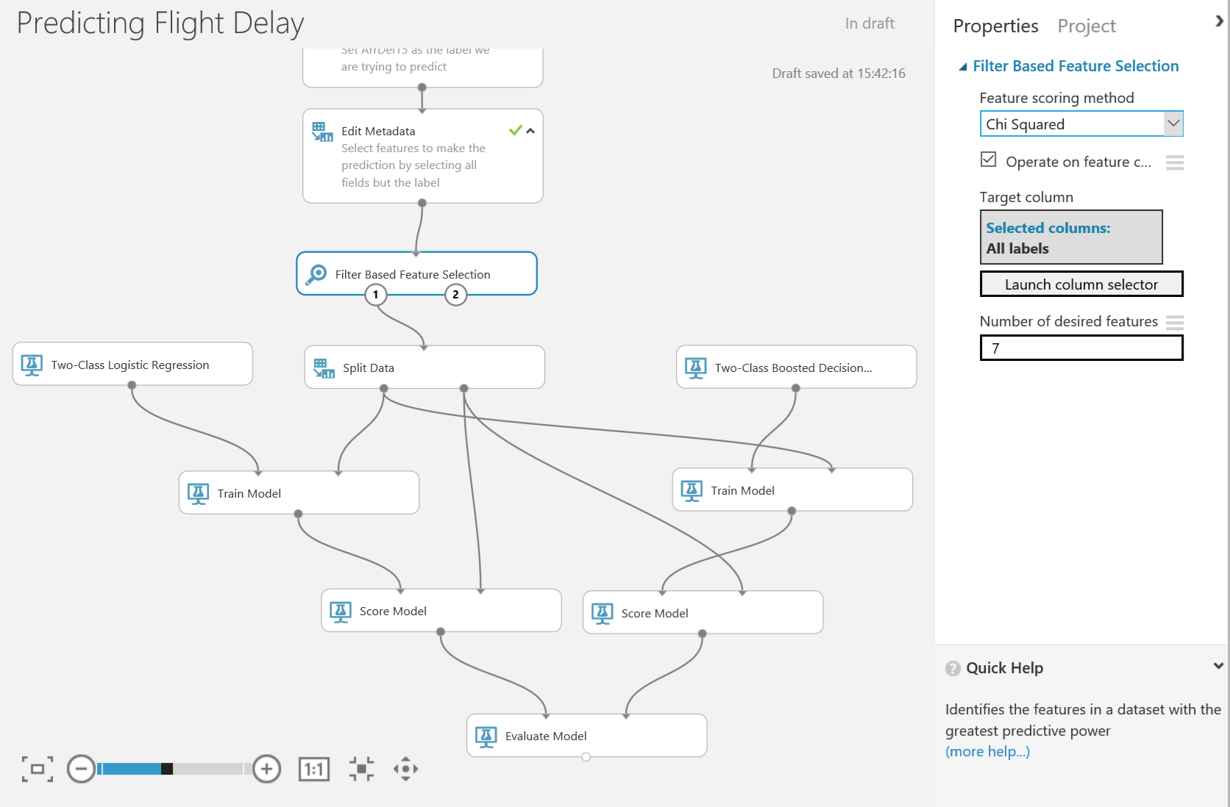

The chi-squared ranking of features in a two class problem finds the features which differ the most between the two classes. Therefore, finding the most significant features that allow you to predict if a flight is delayed or not.

Now we can see the top 7 features that distinguish the two classes (delayed or not) from the right output port of the ‘Filter Based Feature Selection’ module.

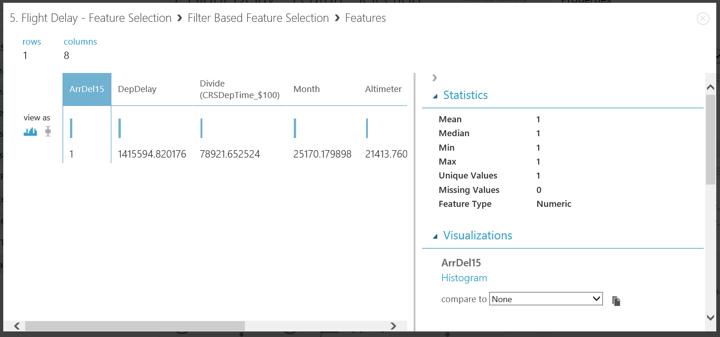

From the left output port of this module we can carry on the experiment with a filtered feature dataset.

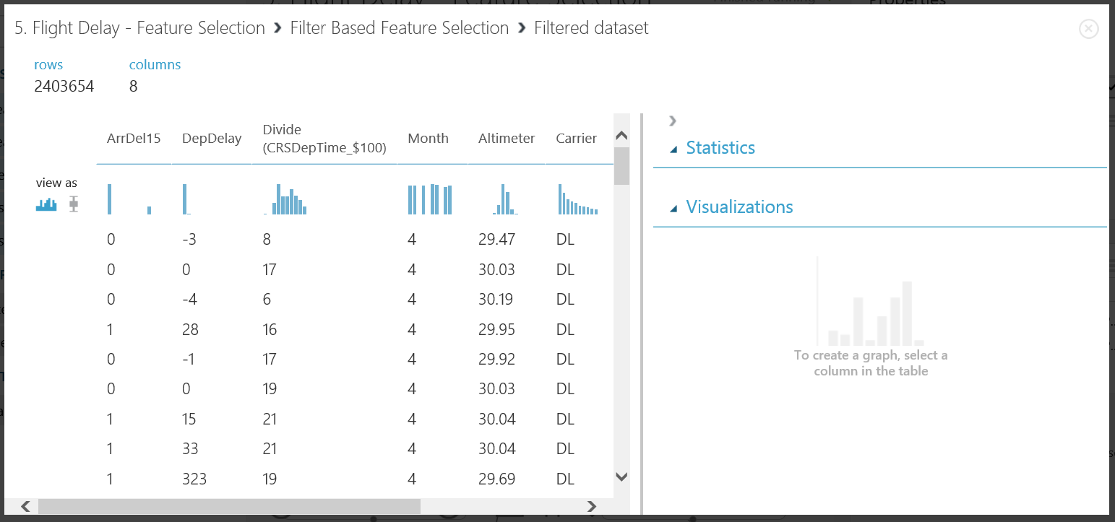

Feature selection has both immediate and future advantages and disadvantages. For example; because we are cutting down the amount of features, we are cutting down the amount of data, which leads to the amount of intricate patterns the model is able to learn is reduced. The result of this change is potentially a lowered accuracy on our validation set, however for future previously unseen data the model may perform better and over-fitting the data is reduced. Another advantage is, less data leads to reduced processing time.

Finally, to optimise our classifier solution we can use a module called ‘Tune Model HyperParameters’. This module allows you to determine optimal parameter settings for a specified classifier.

Drag and drop a ‘Tune Model HyperParameters’ module onto the work space and set the parameters as shown below. This module has 3 input ports and 2 output ports. The extra port can be populated with additional data not seen when training to validate the best answer and avoid over fitting. However, to ensure we properly validate this experiment we should use data for scoring not seen by the ‘Tune Model HyperParameters’ module. To do that cut and copy the slit parameters module we already have and set it to a 0.5 (50/50) split. Wire up the connections as shown below and then set the properties of the ‘Tune Model HyperParameters’ as shown below.

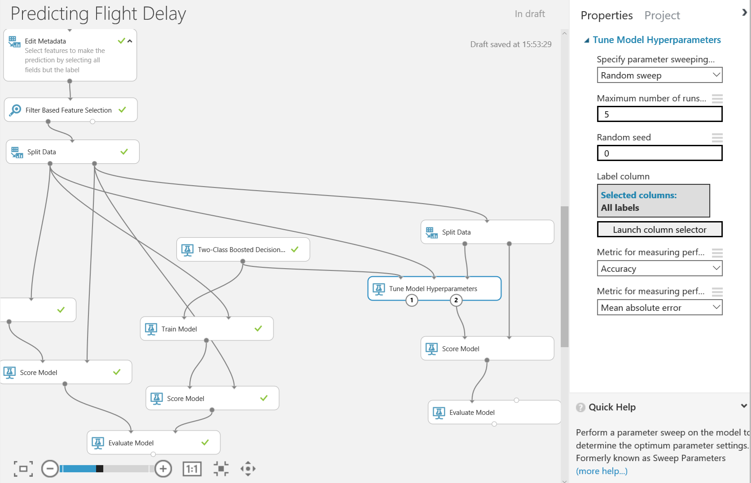

The right output (2) of the ‘Tune Model HyperParameters’ module now contains the best trained model which has optimised parameters for the total sweep runs completed. We can now complete the diagram above by connecting that output to a score model module and connect that in turn to an evaluate model module as shown above.

If we now run our experiment again (which may take more than five minutes) then we’ll see the results of the iterations we have selected by selecting visualise from port 1 of the ‘Tune Model HyperParameters’ module.

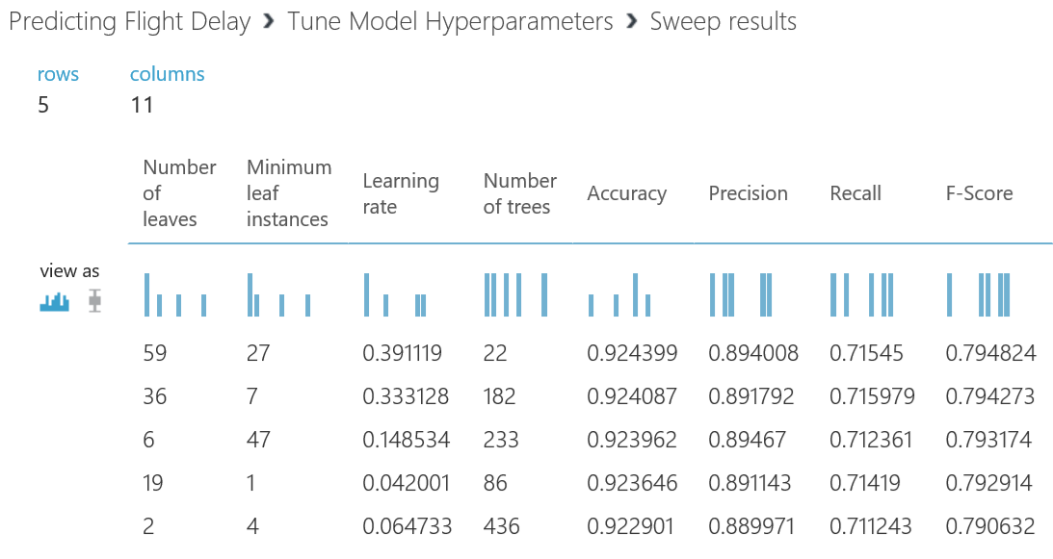

There is a marginal increase in precision as a result of this, which shows that the default values for the Boosted Decision Tree algorithm are pretty good and would only need to be tuned in unusual situations and then probably by an expert.

We can also see how the ‘Tune Model HyperParameters’ module improved the AUC by selecting visualise from the left hand port of this module.

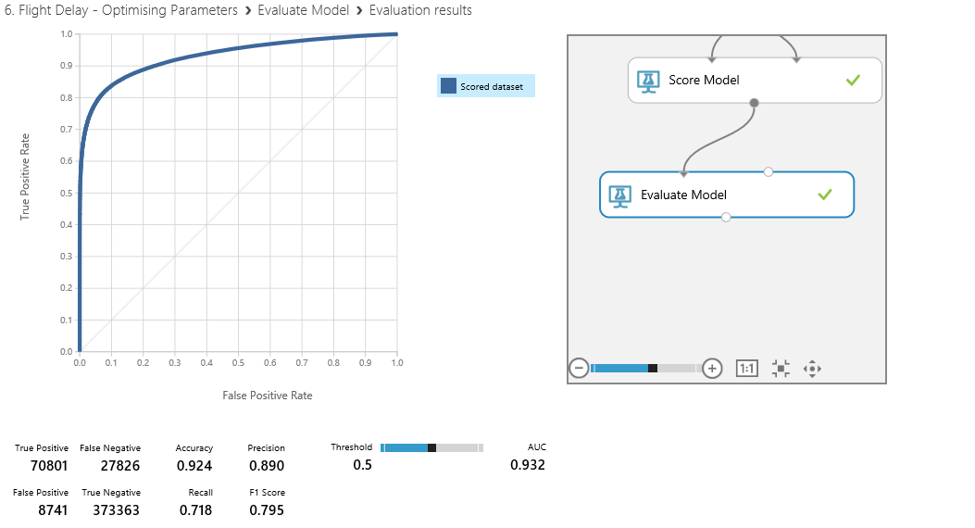

That shows how we can use the more advanced features in Azure ML to tune our model and assess how successful it is. The grid of numbers under beneath the RoC curve are known as a confusion matrix the descriptions. In this case a true positive is a correct prediction of a late flight and a true negative is the correct prediction of a an on time flight the other less obvious statistics are calculated as follows:

* **Accuracy** = true Positives + True negatives over the overall total = 0.922
* **Recall** = true positives divided by true positives + false negatives = 0.684
* **Precision** = true positives divided by true positives + false positives = 0.913
* **F1 score** = .2 * (precision* recall)/ (precision + recall) = 0.782

Do bear in mind that this depends on what success looks like, for example:

* Accuracy at any cost
* Speed
* The best result using the minimum amount of data is it accuracy.

There is no right answer here it depends on the business problem we are trying to solve. If you want to reproduce this output yourselves there are two optional labs at the end of this document one for Python and the other for R.

# Creating a Scoring Experiment

We have cleaned our data, we have trained a classifier and we have re-iterated over our experiment to improve the accuracy of our classifier. Now we want to use one of Azure ML’s key features – operationalising the classifier. In order to create a web service for this classifier we first want to create a Training Experiment. You can then publish this to the ML API service to make it available for other users or applications to use as a web service or a REST endpoint.

This may sound like a hard task, however once your experiment has been run successfully - there are green ticks by each module you will see a button on the toolbar at the bottom of the screen become active

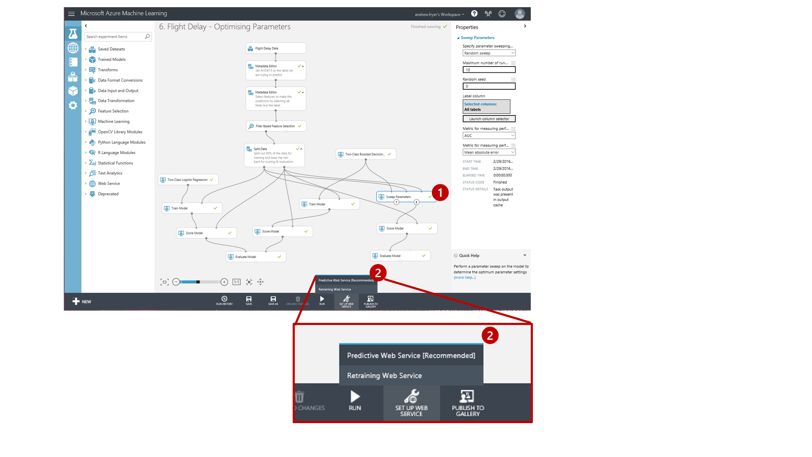

**\*Note:\*** Make sure you select the module that you want the studio to save as your best trained model. In this case we select the ‘Tune Model HyperParameters’ module.

After clicking the ‘Predictive Web Service (Recommended)’ option our experiment appears to get redrawn and consolidated. Actually what has happened is that ML has created a new Predictive experiment tab at the top of the screen.

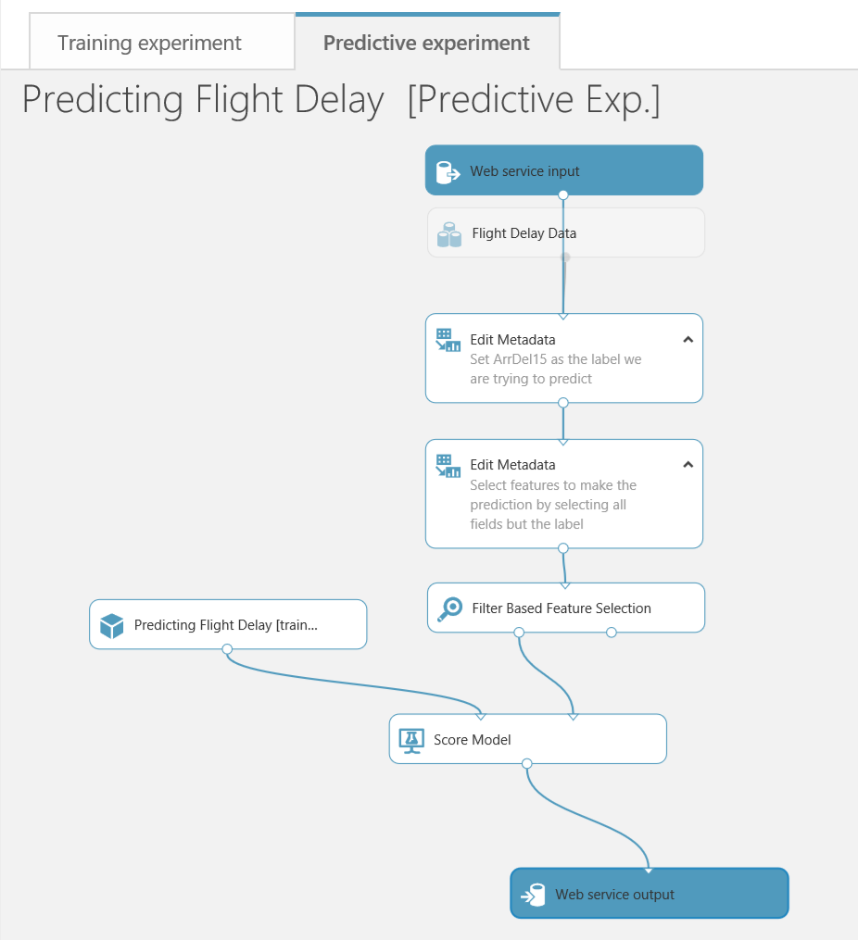

and this is what we are looking at. Our original experiment is still there as it was on the training experiment tab.

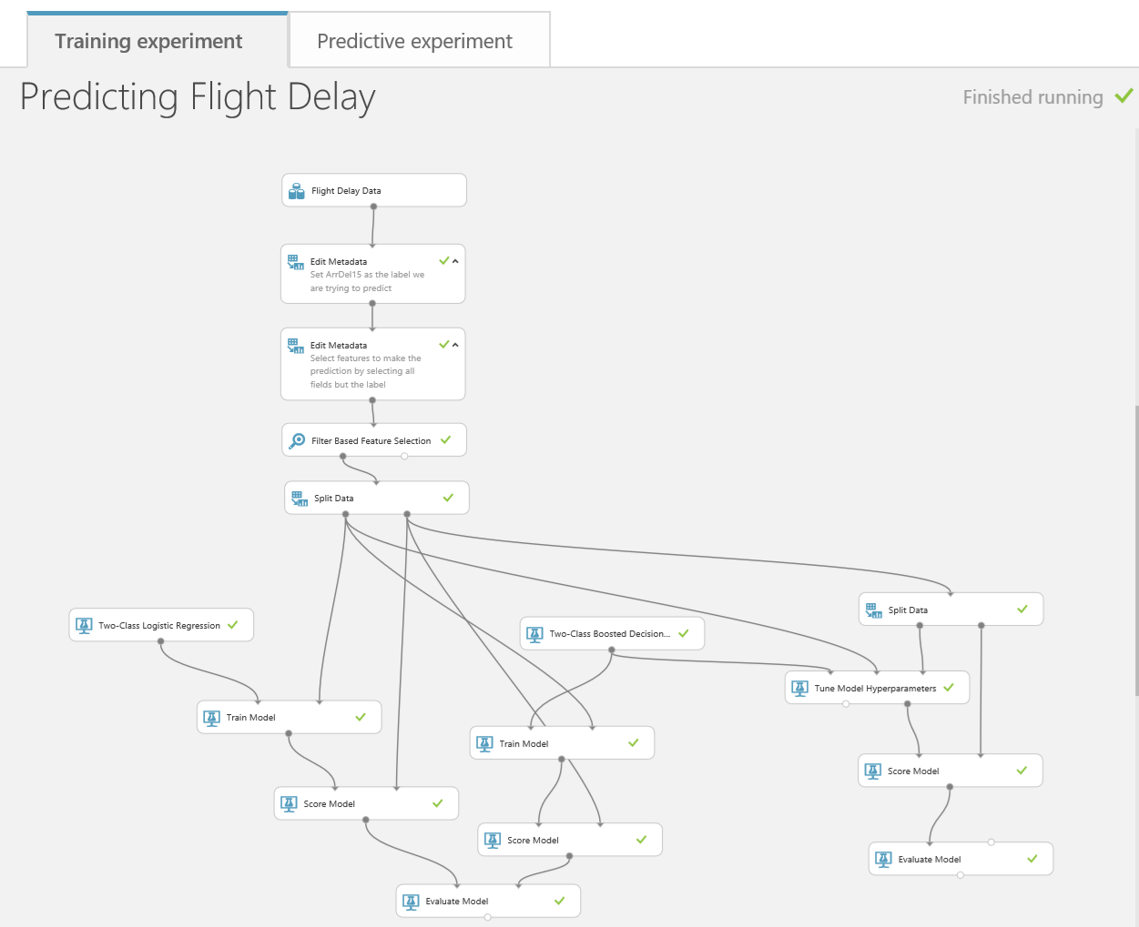

If we go back to the Predictive experiment tab we can review what has happened in this new experiment.

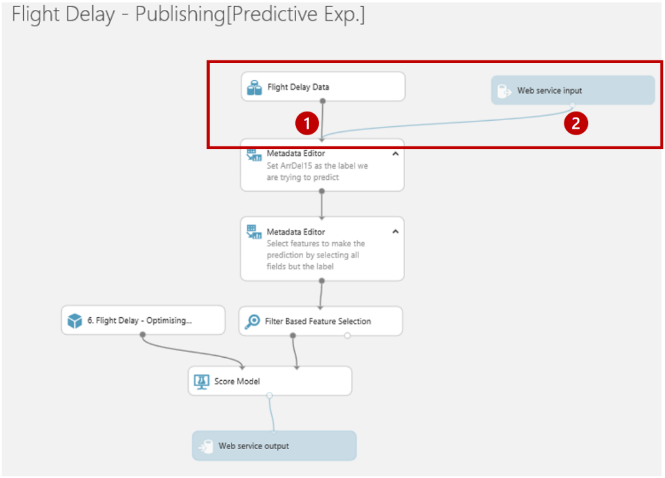

Firstly, there are two new modules in blue, “Web service input” and “Web service output” which represent the data format that will flow into and out of the web service we are creating. If we move the modules around as show we can see this more clearly.

The Web service input (2) will use the same fields as the input to the module it is connected to (1).

The wizard has done a good job of placing where the input and outputs on our predictive experiment it is not perfect. The data flowing through feed 1 in the above diagram contains our label (ArrDel15) which is what we are trying to predict. While this is valid for training we shouldn’t have it here so we can eliminate it by moving the Web service input to connect with the score model module and adding a ‘Select columns in a Dataset’ module as shown and set this to exclude all ->ArrDel15.

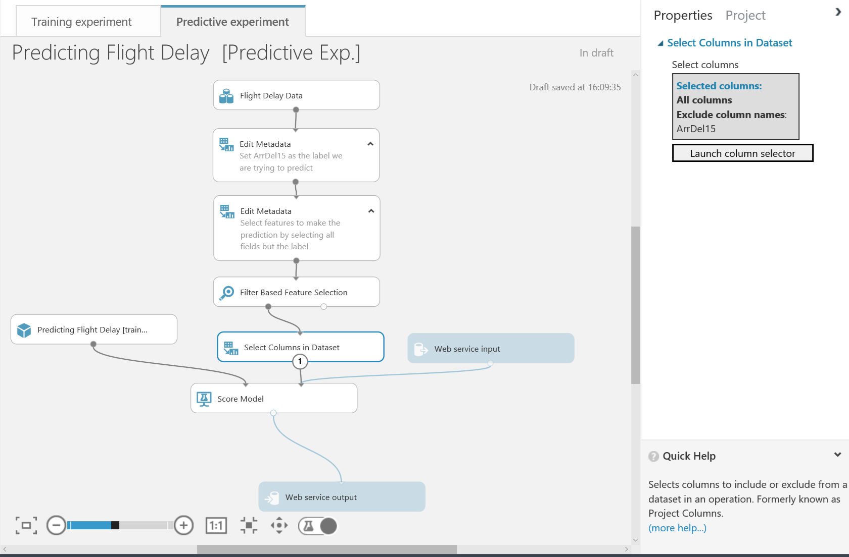

If we think about what fields we want to return to the application or web site that will call our web service we are creating, then all we need to return are the scored labels (the prediction) and scored probabilities (the probability of the prediction being true). So we should add another ‘Select columns in a Dataset’ module as shown to just return those fields.

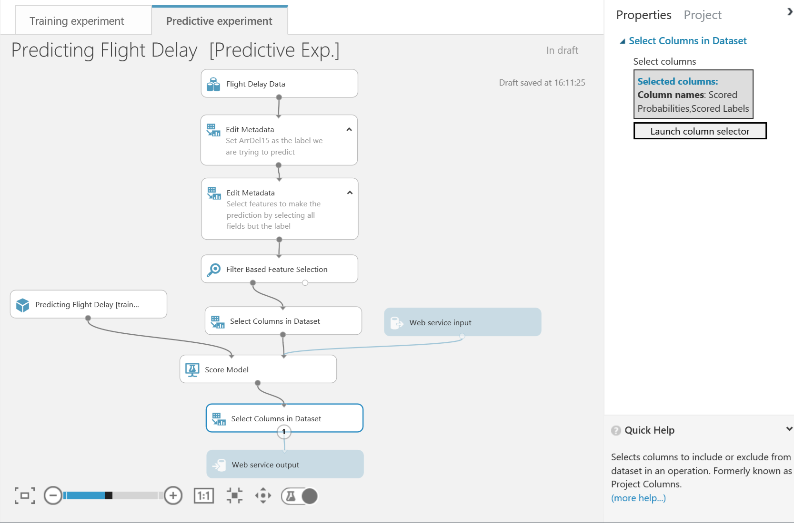

We must now run this predictive experiment as this allows ML to validate the predictive experiment before we can publish it as web service.

While that is running we can notice a couple of other things about this predictive experiment. There is a new module which is simply a placeholder for the training experiment.



Also notice there is a toggle switch 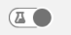 at the bottom of the screen to move between web service and experiment views. In web service view we can rename the input and output e.g. input1 to flightdata and output1 to flightprediction to make it easier for developers to use the service.

**Note** Putting spaces in these values leads to problems with the API.

# Publish as a Web Service

The aim of this section is to publish a Web Service in order to operationalise and deploy a trained model to production. The Web Service consists of a Web API which can be consumed from other applications.

**\*Note:\*** the best trained model created automatically also appears under the Trained Models category on the left-hand side of the page. This implies the new train model can be used in future experiments as a standalone module.

Now all we need to do is to check our experiment has been saved and run. Now the ‘Publish Web Service’ option at the bottom of the screen is available.

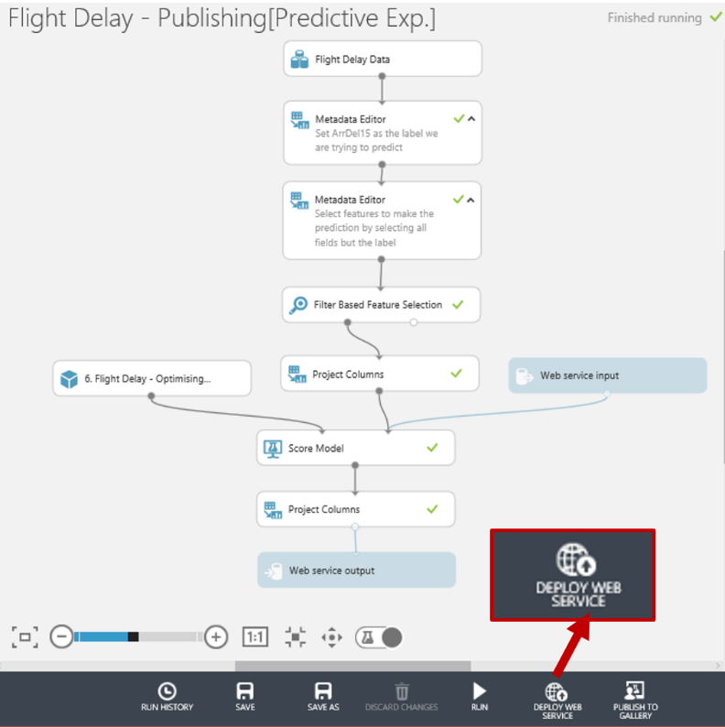

So let’s click on it and we’ll have a web service we can now use with any website or application capable of making a call to a rest api

# Testing the Web Service

In this section, we are going to look at the published Web Service and try to predict if a flight will be delayed or not based on some input data. After the Web Service is published, we are automatically redirected to the Web Services page  for this experiment within ML Studio. In the Dashboard tab, we can see some general information about the WEB API like the API key which is will be used for authorization purposes. There are also hyperlinks to help pages for the two endpoints of the service, a Request/Response endpoint and a Batch Execution endpoint. Notice we are also given some Excel spreadsheets where we can test the service as well.

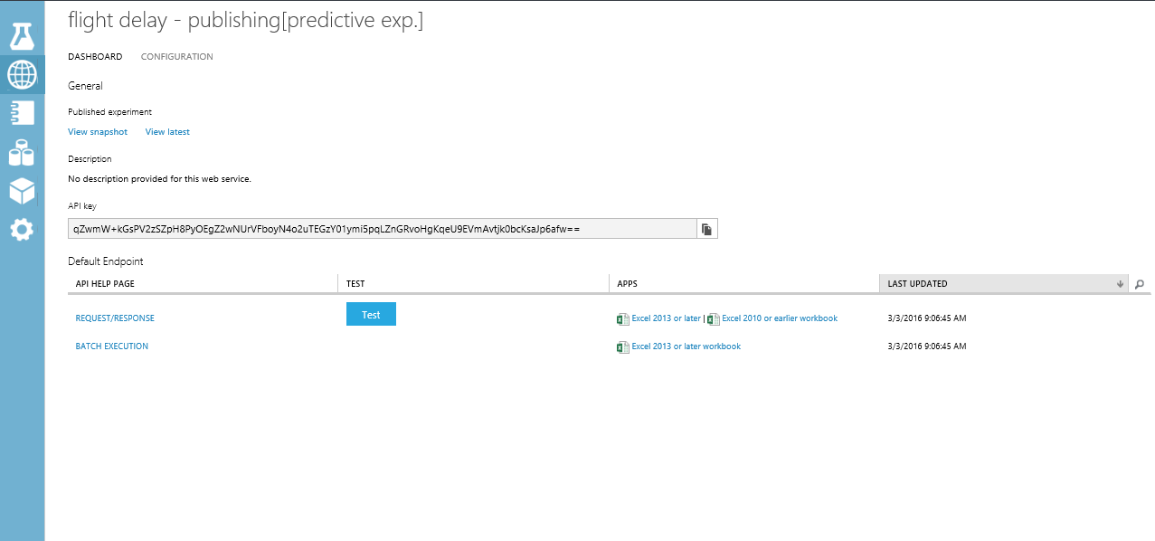

The Configuration tab allows you to change the name and description of the Web Service. Additionally, you can add descriptions for the input schema. For now, click on enable sample data and go back to the dashboard.

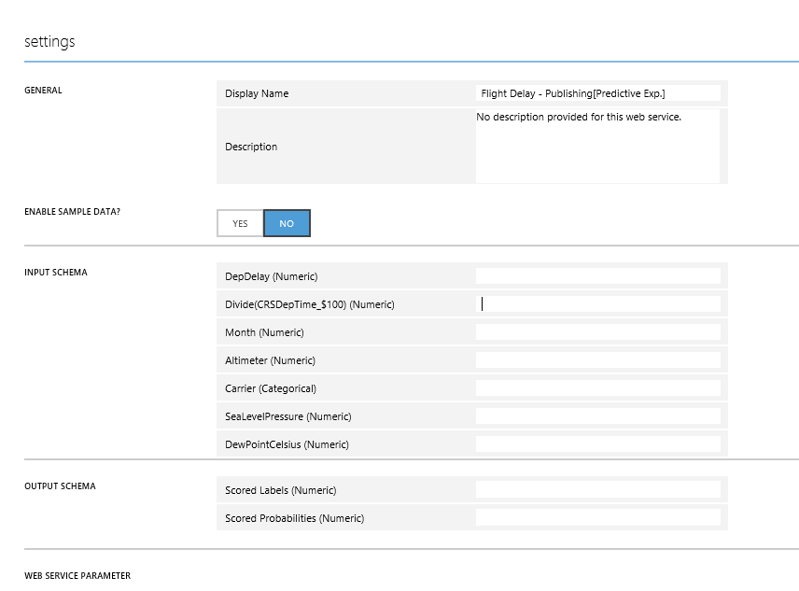

On the Dashboard tab click on the button alongside the REQUEST/RESPONSE API as a quick sense check to see if our web service is working as expected.

Enter the following values in the Enter data to predict dialog:

* **DepDelay =** 33
* **Divide(CRSDEPTIME_$100) =** 8
* **Month =** 4
* **Altimeter =** 29.6
* **Carrier =** DL
* **SeaLevelPressure** 30
* **DewPointCelcius =** 1.7

The result you receive back after processing returns a JSON like output.



Notice we just get back the Scored Label and the Scored Probabilities. So in the case below we can say that given the parameters above the classifier has predicted the flight will be more than 15 mins delayed (1) and it is very confident in its decision (0.997861325740814).

We can also use the excel add-ins to test the web site and there is also a partially configured web site in the [Azure Web App Marketplace](https://azure.microsoft.com/marketplace/web-applications/all/). Simply go to the site and look for Azure ML.

This will create a web app in our azure subscription.

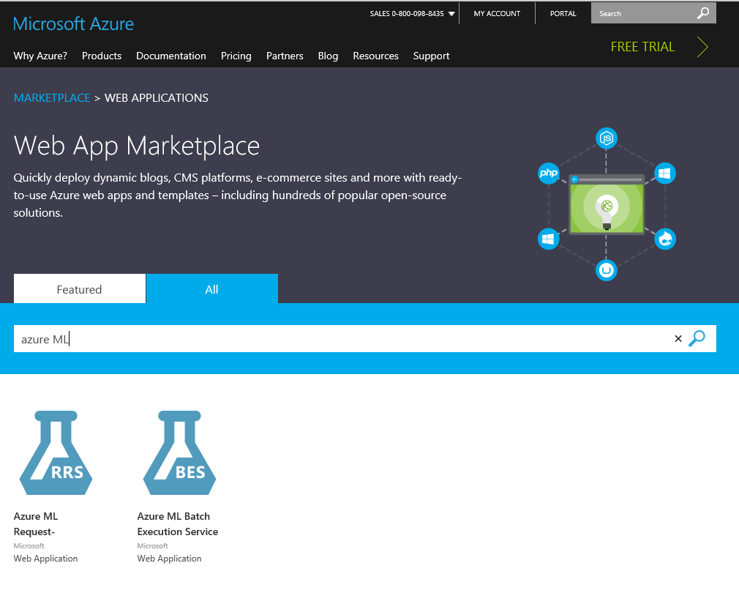

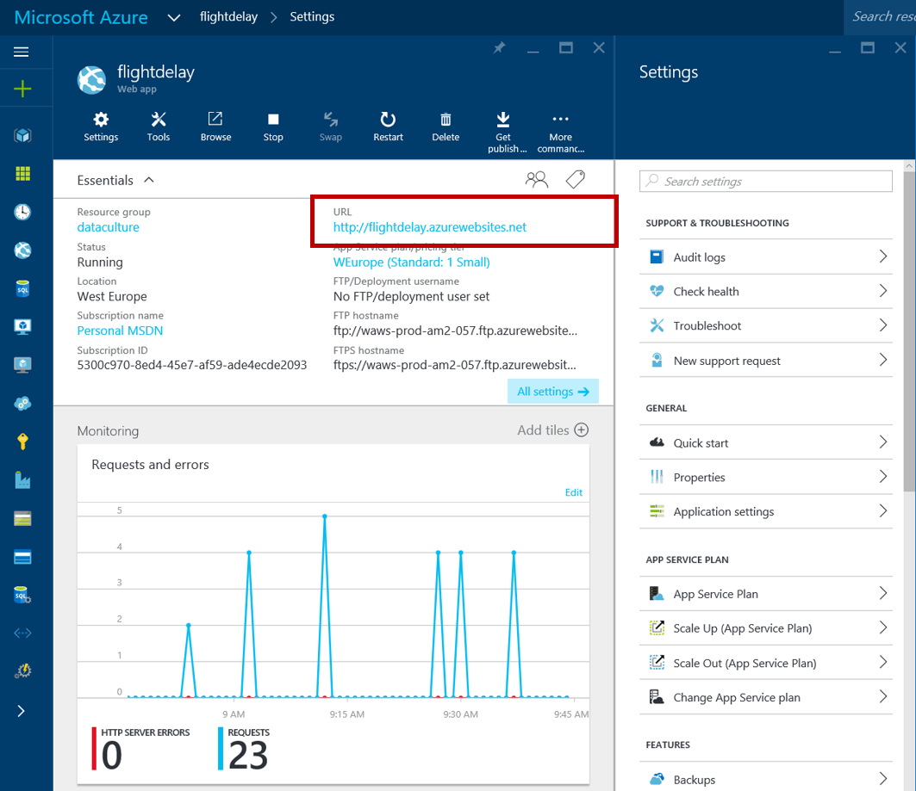

If we then click on the URL of the new site we’ll be presented with a simple page where we can enter our API URL and API key ..

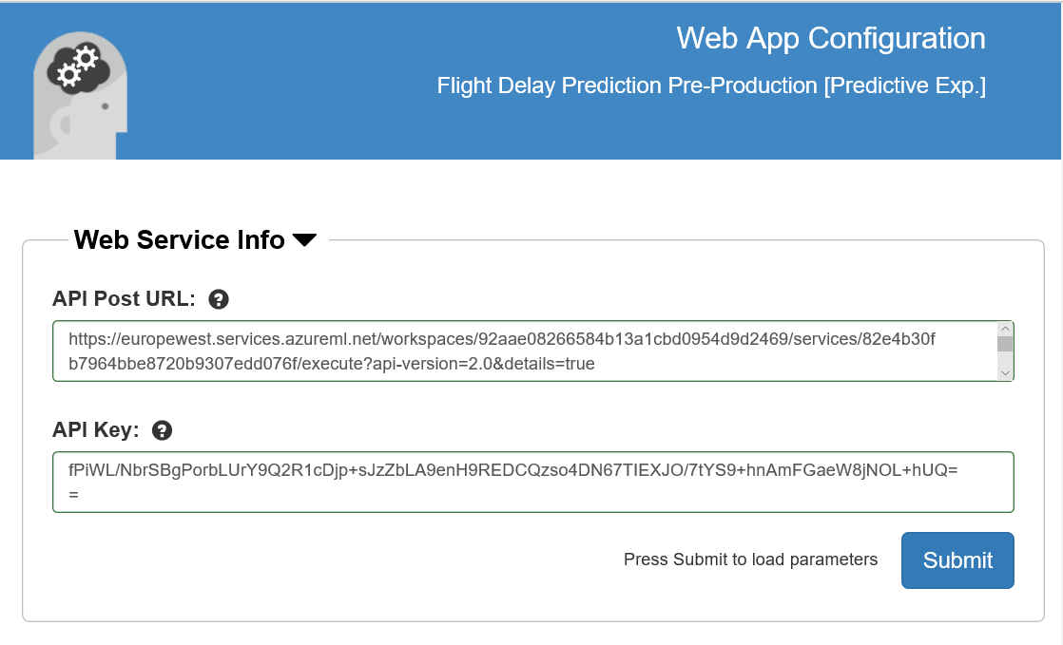

The key is on the API dashboard and the URL is at the top of the Request response page. Click Submit and close the page. Go back to the Azure Portal and open the site again and enter some trial values..

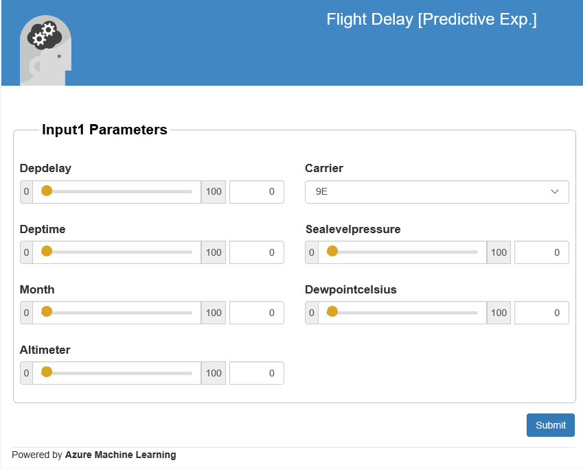

Optionally try the Excel spreadsheet to see how that works if you have Excel on your machine. Below is what the Excel 2013 version looks like which uses the new Excel add-ins to automatically setup a connection to the API we have and also allows us to use sample data to test.

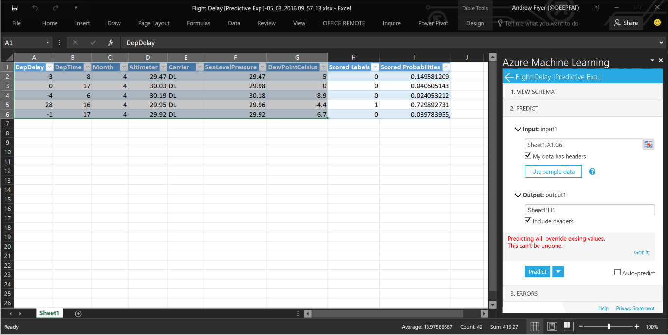

# Publish to the Gallery

The most recent release of Azure ML includes a community-driven gallery that lets you discover and use interesting experiments authored by others. You can ask questions or post comments about experiments in the gallery and more importantly publish your own!

The gallery is a great way for users to get started with Azure Machine Learning and learn from others in the community: <https://gallery.azureml.net/>

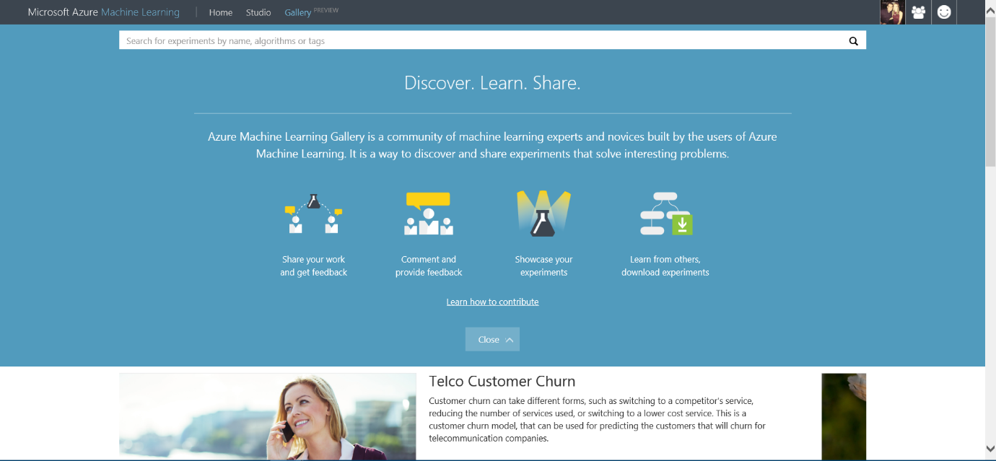

You can access this gallery via the URL above, or if you are already in the studio you can click the ‘Gallery’ option in the top toolbar:

In order to publish your own experiment, you need to have met the conditions below:

1. You have created an experiment in Azure ML Studio
2. Your experiment runs (all green ticks)
3. You have created a web service and scoring experiment

It is that easy! So everything we have done in this lab has meant that we could publish our experiments in the Gallery. As you will notice in your experiment workspace the ‘Publish to Gallery’ option in the bottom toolbar has become available

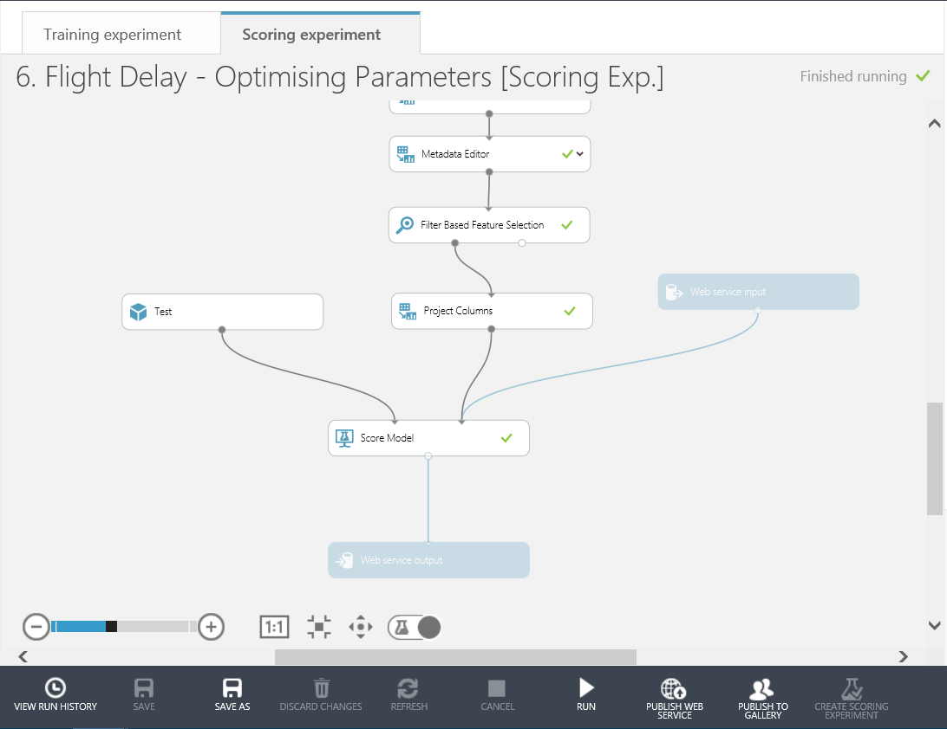

This will take you through various stages to Name, give a description, image and tags for your experiment. Then publish it to the Gallery for you.

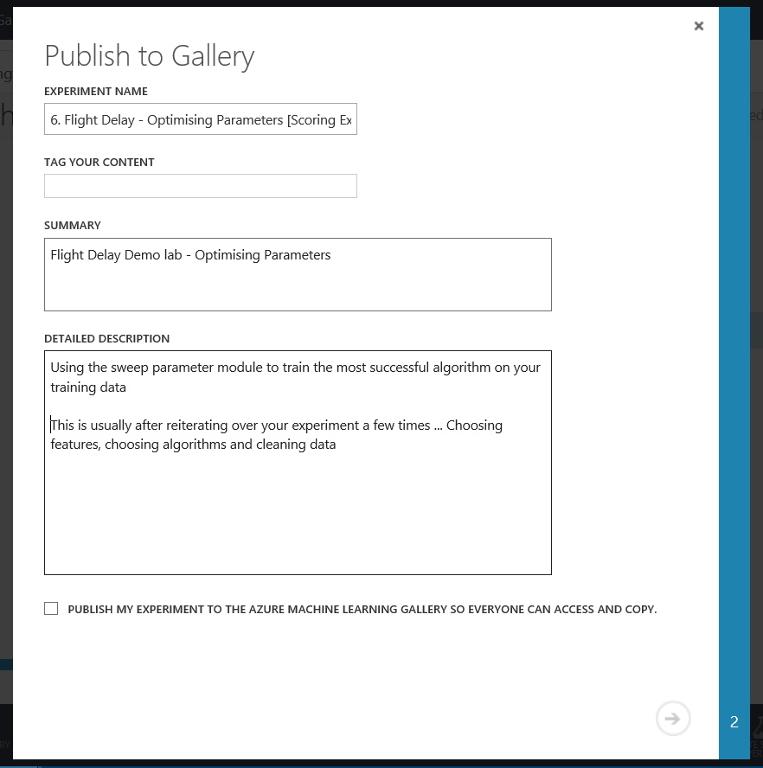

The experiment we have created in this lab is now available in two forms in the gallery. Check them out here:

Flight Delay Pre-processing stage: <https://gallery.azureml.net/Details/cc618dd8dfb14af0a6354c01ffd606e6>

Flight Delay Web Service stage: <https://gallery.azureml.net/Details/bc3008585f374b62be54d4e57ae8a240>

# Conclusion

This lab was intended to introduce you to the basic concepts of Machine Learning such as binary classification, feature selection, training and testing a model and using Azure Machine Learning. A web service was created to operationalize and deploy the model for production.

**Next Steps:**

* Check out the UK Data Developer page on MSDN here:
* Check out the Azure ML Gallery and download and edit/run other types of machine learning experiments: <https://gallery.azureml.net/>
* Also check out other Azure Services that can be used with Machine Learning such as HDInsight, Data Factory and Stream Analytics: <http://azure.microsoft.com/en-us/services/>

# Optional Lab: Data Processing

Open Azure ML studio and sign in if necessary.

In this experiment we will use the saved datasets ‘Flight Delays Data’ and ‘Weather Dataset’ from the Module menu on the left side of the studio. Click and drag these on to the experiment workspace

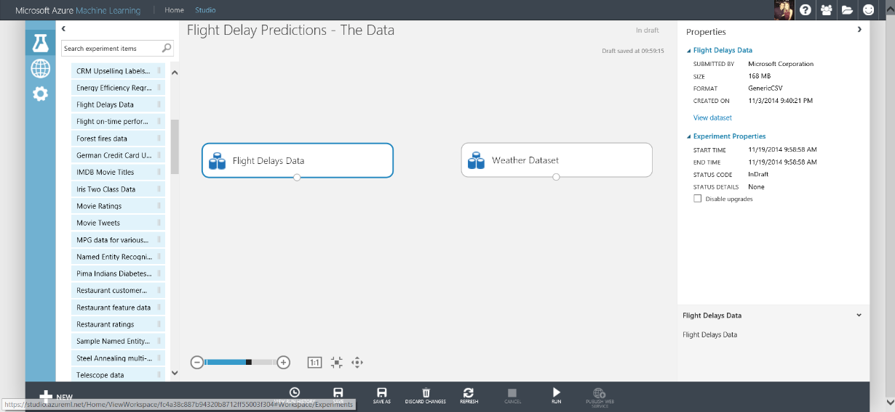

Right click on the small dot at the bottom of the Weather Dataset module and choose ‘Visualise’. This view shows you the first few rows of the dataset and also various statistics about each column in the dataset. Notice, some of the rows which should be Feature Type = Numeric are actually FeatureType = String, for example ‘DryBulbFarenheit’

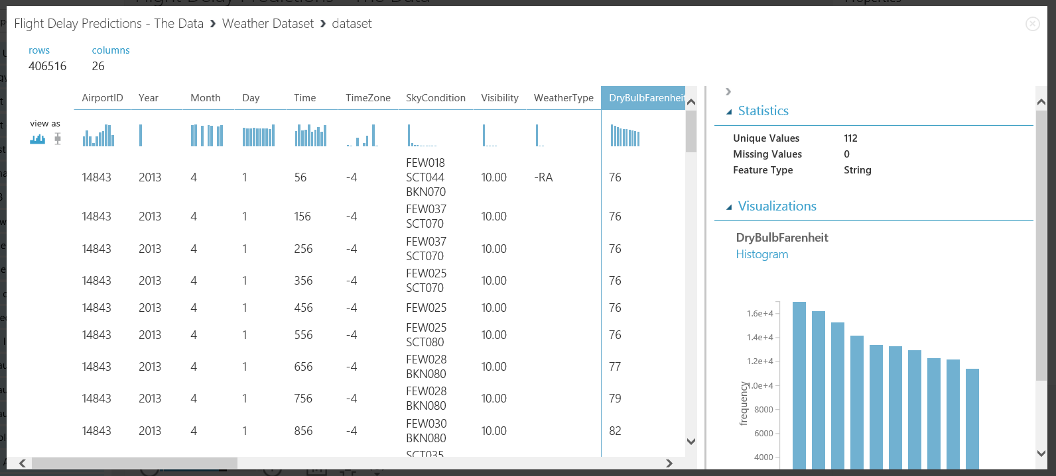

In order to solve this problem, drag and drop the ‘Convert to Dataset’ module and set missing values to ‘?’. Next connect the datasets and ‘Convert to Dataset’ modules together for both flight and weather data. Then Save and Run the experiment using the buttons in the bottom toolbar.

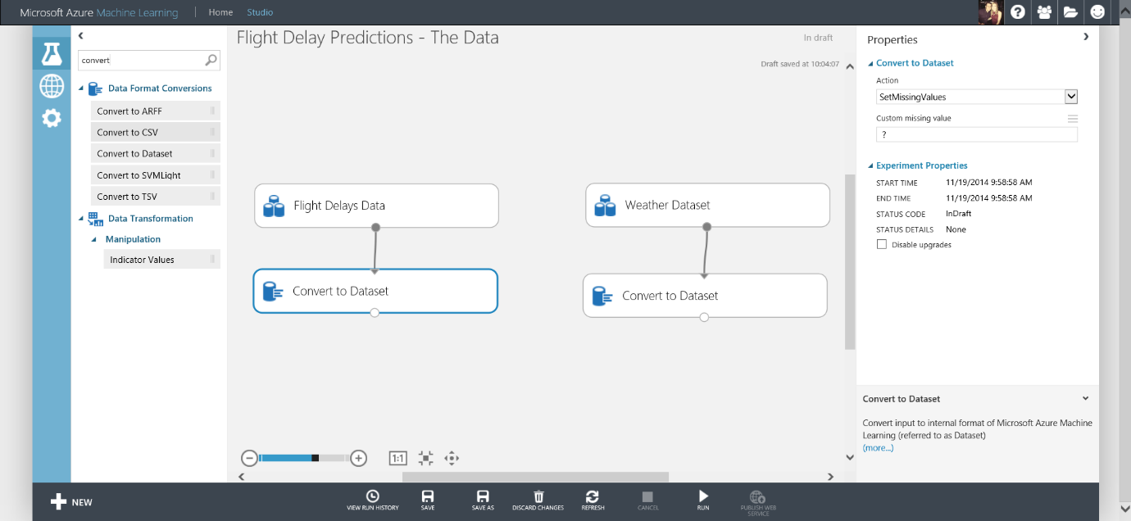

**NOTE:** The ‘Custom Missing Value’ parameter for ‘Convert to Dataset’ module must be set to ‘?’ for flight delay and then ‘M’ (uppercase) for weather data. These are key symbols.

A top tip, you can type keywords into the search box on the left side of the workspace to find relevant modules to drag and drop into the experiment.

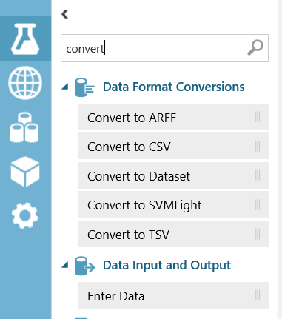

When you see small green ticks by each module the experiment has run successfully. Now if you right click the bottom of the ‘Convert to Dataset’ module and choose ‘Visualise’ you will see the Feature Type is now correct for DryBulbFarenheit; numeric.

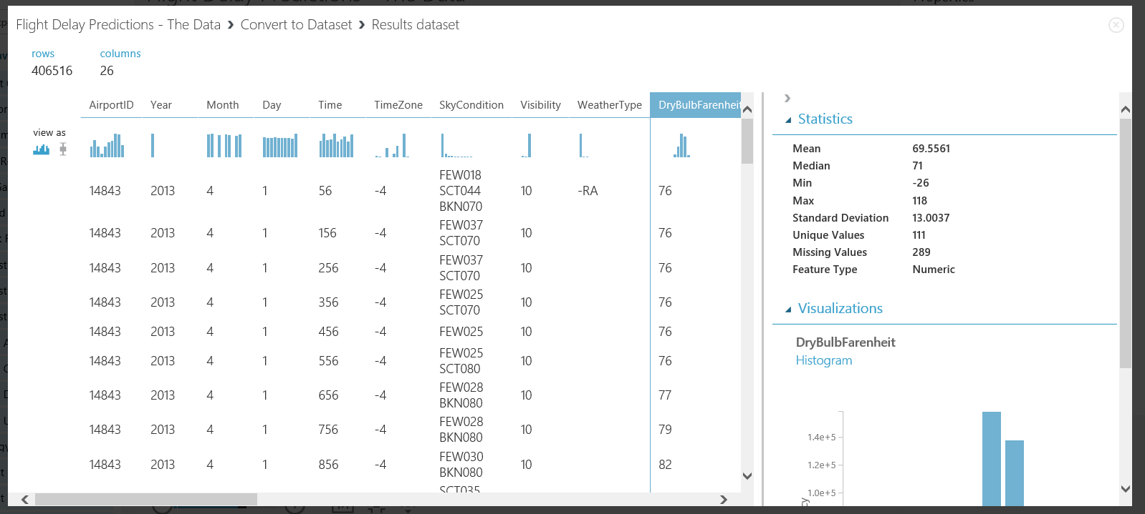

You have successfully completed selecting and converting the datasets, you are ready for further pre-processing.

The aim of this section is to get the data into a clean format and choose necessary data needed to train a model to predict if a flight is delayed or not.

There are many columns in both the Flight Delay and Weather datasets, some of these are not needed to predict if a flight is delayed or not, therefore to reduce computation time we will remove these columns

Drag and drop a ‘Select Columns in Dataset’ module onto the workspace and connect to the Flight Delay data branch of the experiment. In the Properties panel click launch column selector and choose ‘All Columns’, ‘Exclude’ ‘Column Names’ shown in the image below

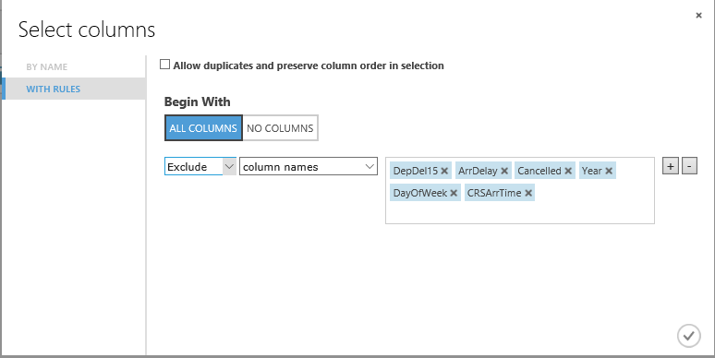

Then do the same for the Weather Dataset branch of the experiment.

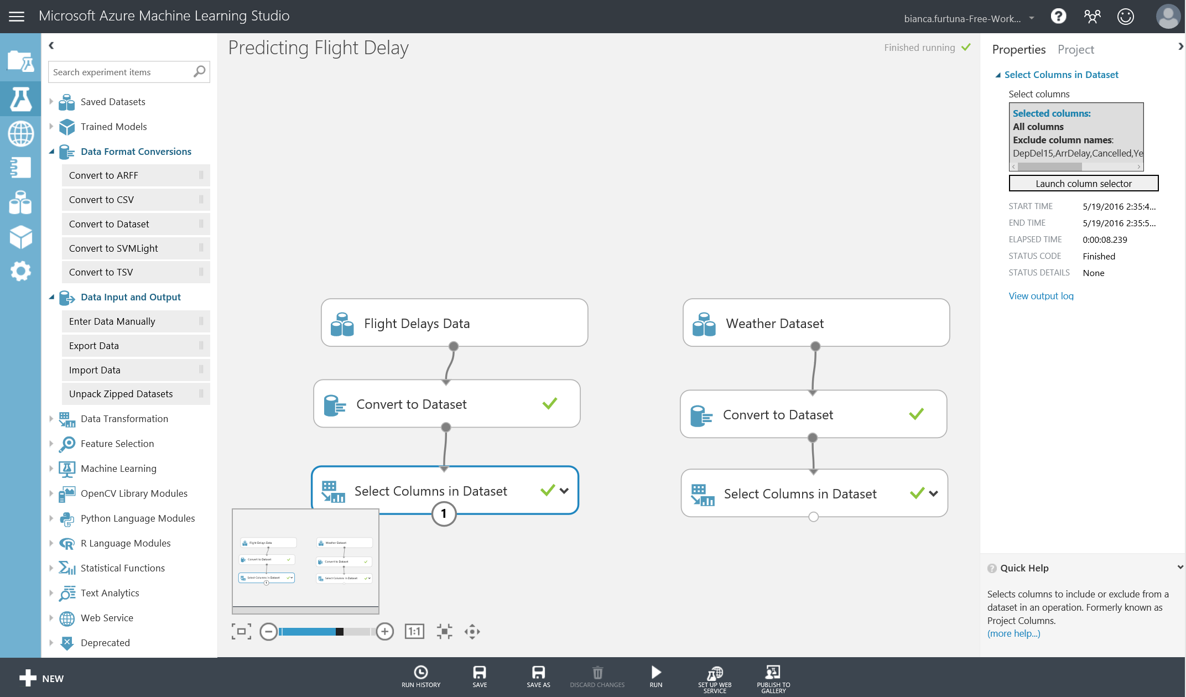

but exclude the column names shown below

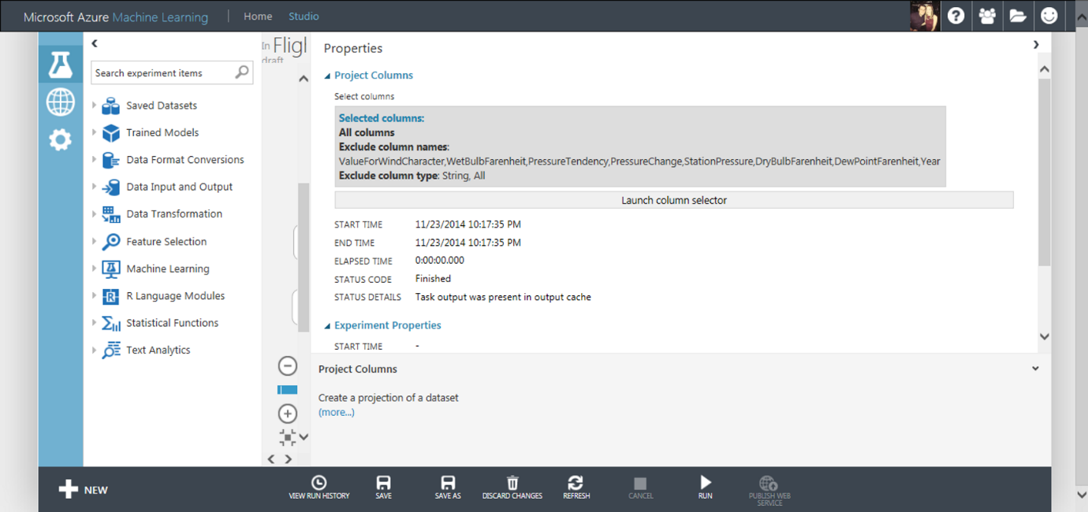

Within both datasets there are some missing values in the data. We want full records of data in order to predict with confidence if a flight is delayed or not, therefore we will eliminate missing values using the Clean Missing Data module. For example, DepDelay in the Flight Delay Dataset has 27444 missing values before applying this module.

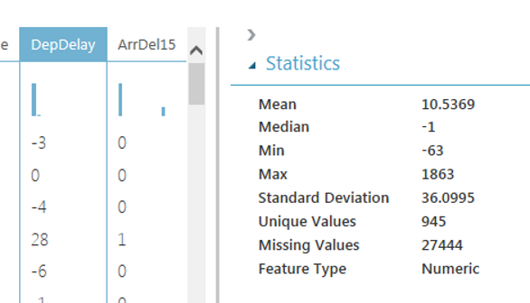

Now drag a Clean Missing Data module onto the workspace and set the properties as shown below.

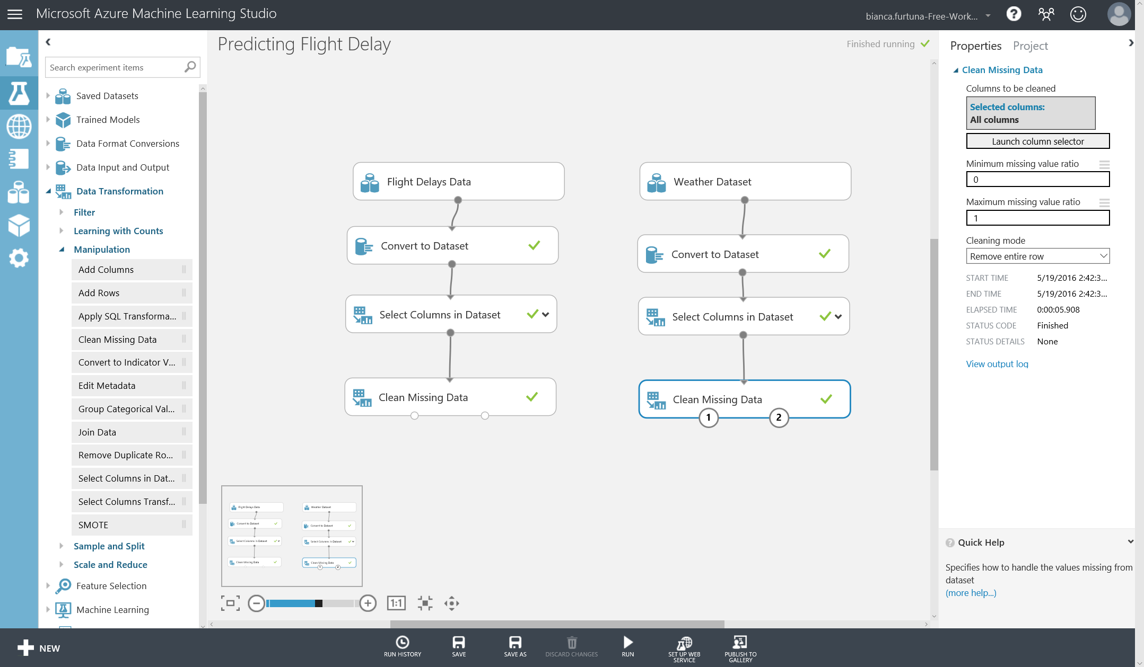

Now Save and Run the experiment. If you right-click and ‘Visualise’ the data now from the left output port of the Clean Missing Values module and select the DepDelay column you will notice the amount of missing values is 0

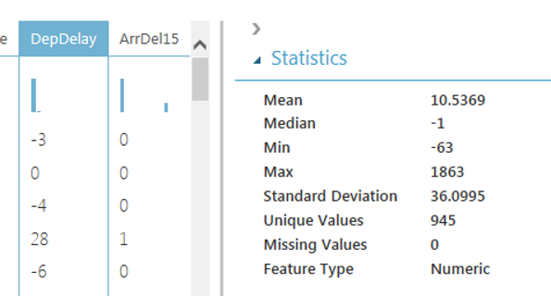

Another useful module when pre-processing data is the ‘Edit Metadata’. This ensure Azure ML Studio handles the data correctly during ML problems. In this experiment some data value are code/ID’s for example AirportID, DestAirportID and OriginAirportID. These are categorical not continuous values and need to be treated as such. Add a ‘Edit Metadata’ module to the workspace and set choose the Carrier, OriginAirportID and DestAirportID columns and set the Categorical dropdown to ‘Make categorical’ as shown below

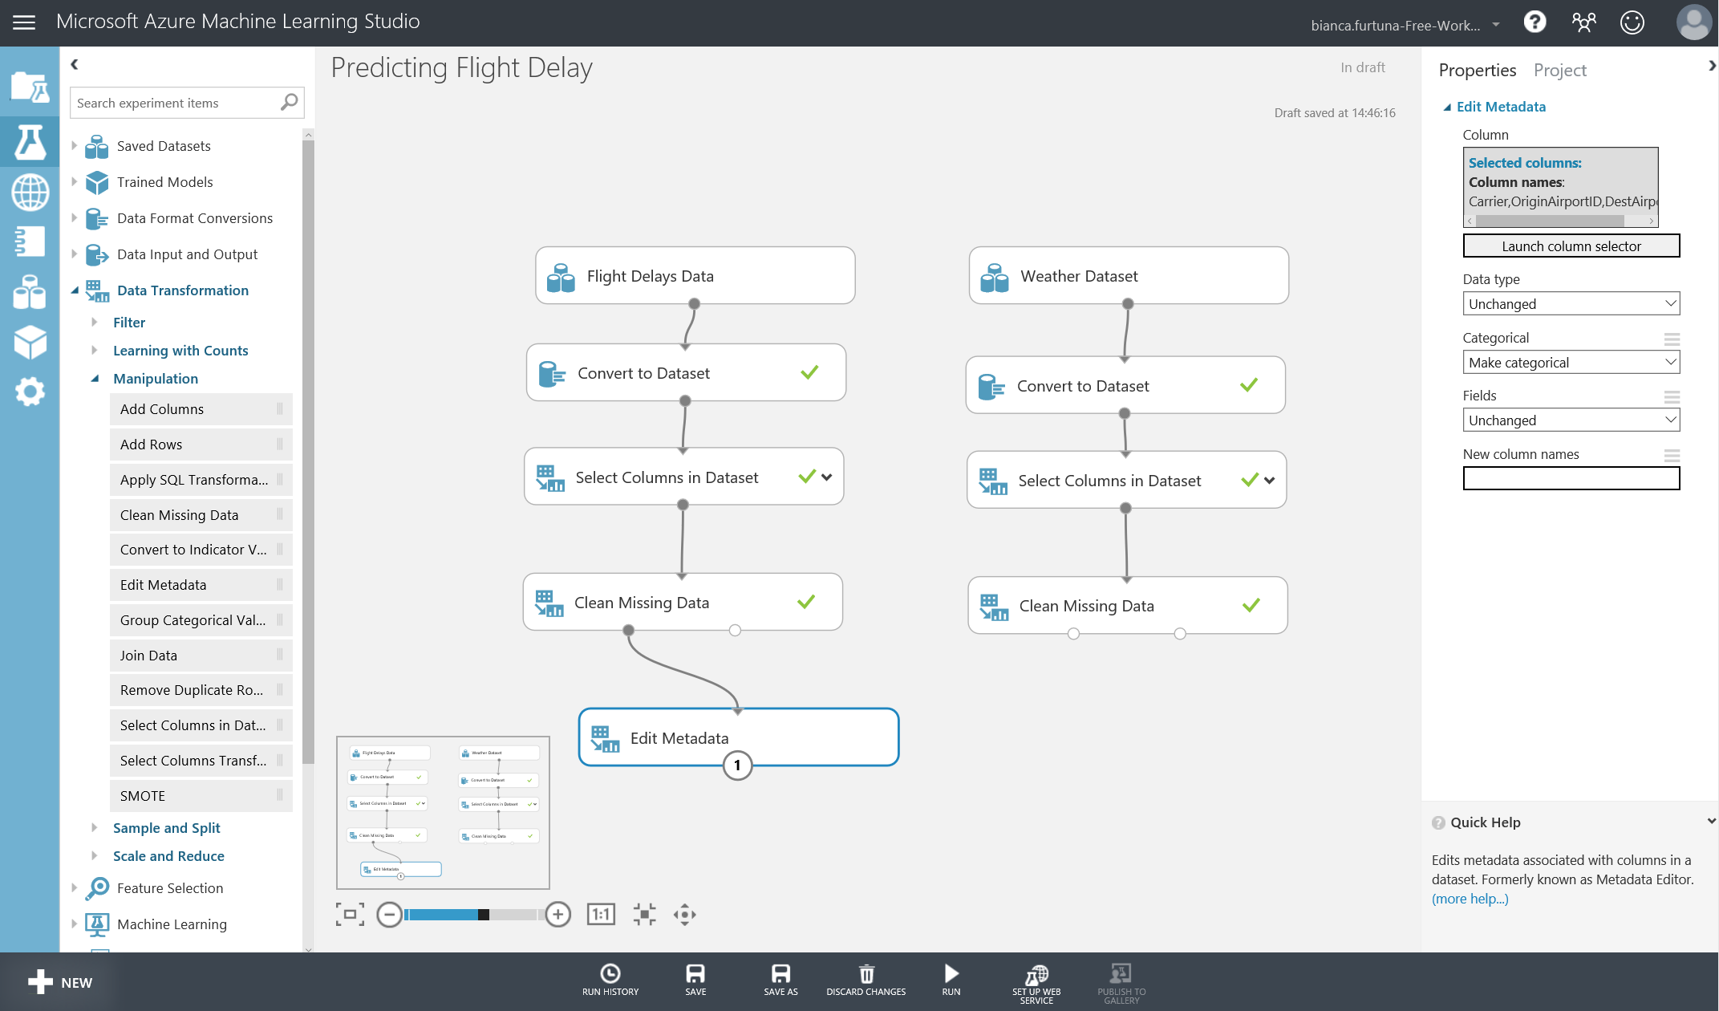

To predict if a flight is delayed we want use both the flight and weather data therefore we need to join the datasets. Currently we have month, day and AirportID that can join in each dataset, however we want to match on the time as well. Currently the flight time is to the nearest minute and the weather time recordings are once an hour at 56 minutes past.

Now we will transform the time and round to the hour. Drag and drop the ‘Apply Math Operation’ module onto the workspace and connect to the Flight Delay Data branch. Set the Properties as shown below:

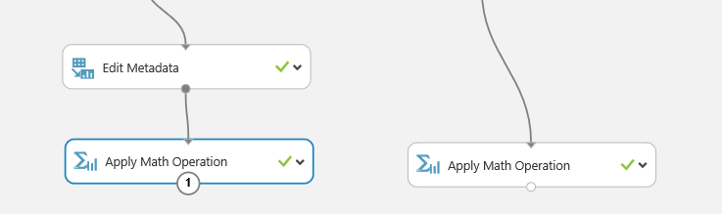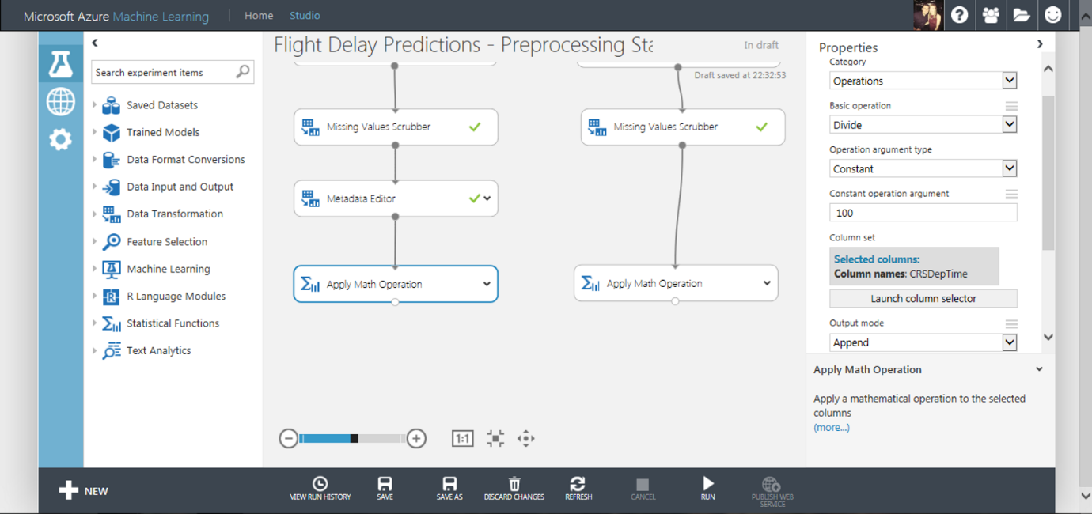

Now do the same operation and apply to the Weather Data branch as shown below:

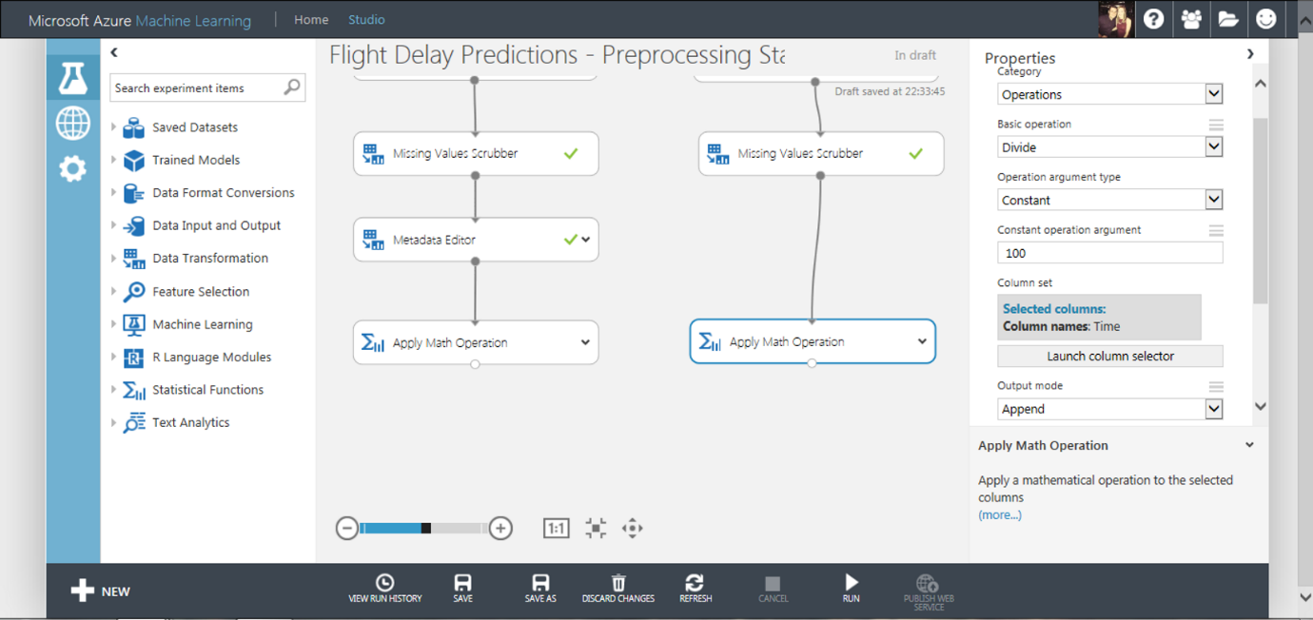

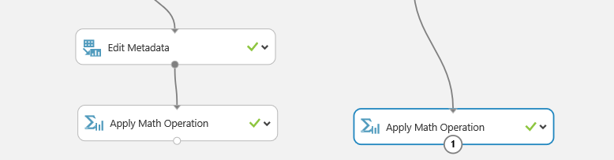

Notice the Output Mode property is set to Append. This will now create new columns with the Math applied and a new name (Divide(Time_$100) and Divide(CSRDepTime_$100)). At this stage make sure you save and run the experiment in order to proceed to the next stage.

Now we will round the time to the hour using the ‘Apply Math Operation’ module, one attached to each branch of the experiment. The properties of each of these modules are set as shown in the images below:

Flight Delay Data Branch: Rounding, Floor, Constant, 1. Select the column Divide(CSRDepTime_$100) and output mode as ‘Inplace’.

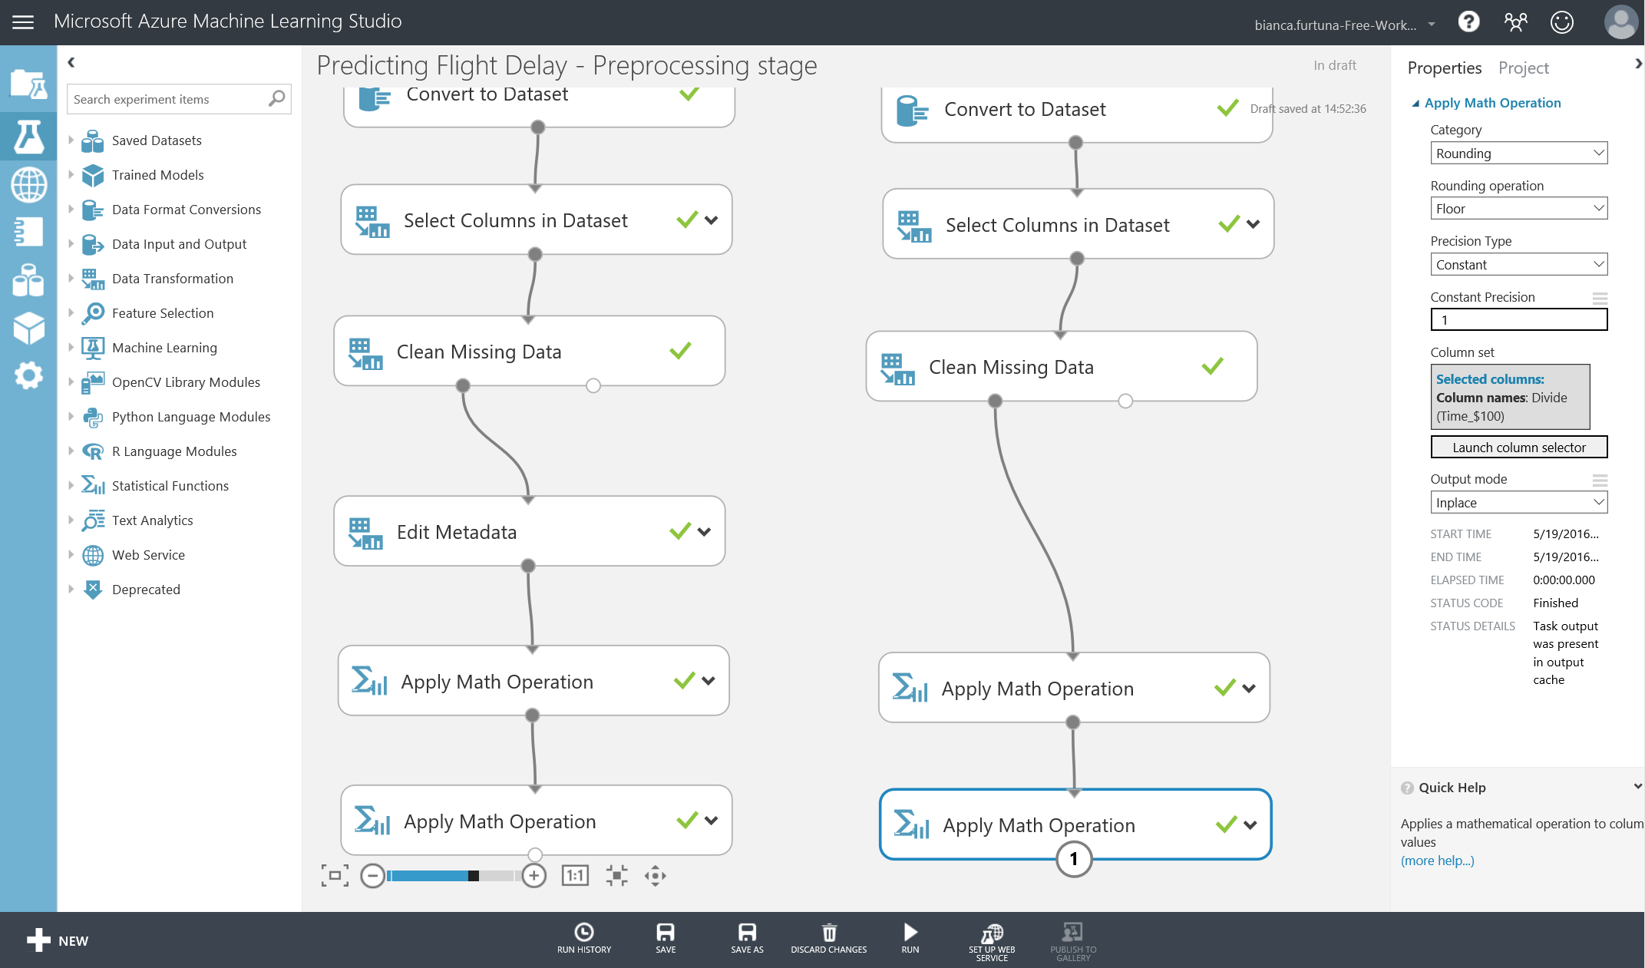

Weather Data Branch: Rounding, Floor, Constant, 1. Select the column Divide(Time_$100) and output mode as ‘Inplace’

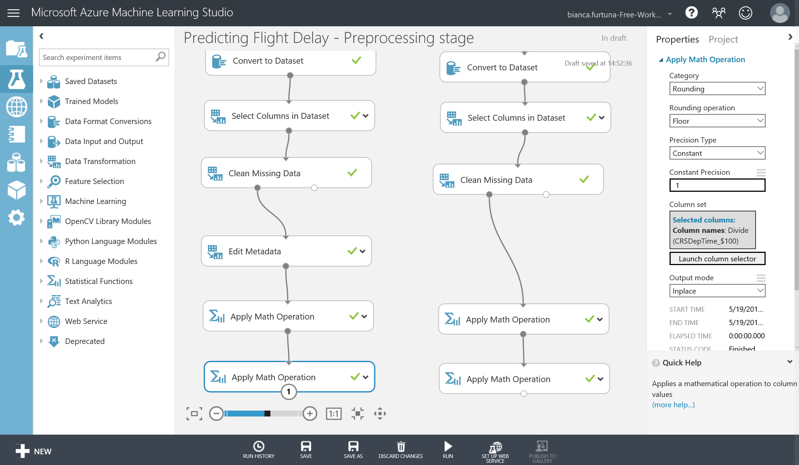

In the weather dataset there are some duplicate weather data rows and we only want one weather reading for each hour of a day. Select the ‘Remove Duplicate Rows’ module and make sure that the filter expression is:

**Column names:** AirportID, Month, Day, Divide(Time_$100)

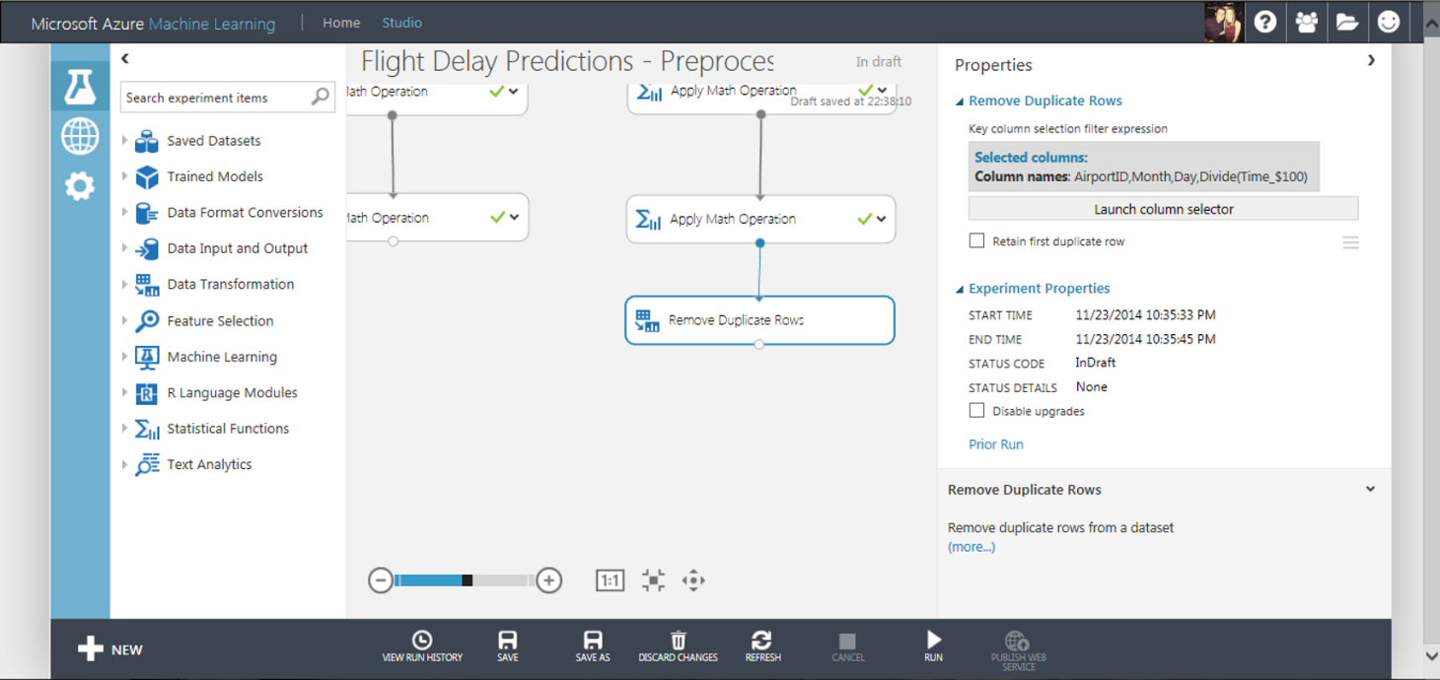

Now the data in each set is aligned, we can use the ‘Join Data’ module to connect the two datasets as shown below

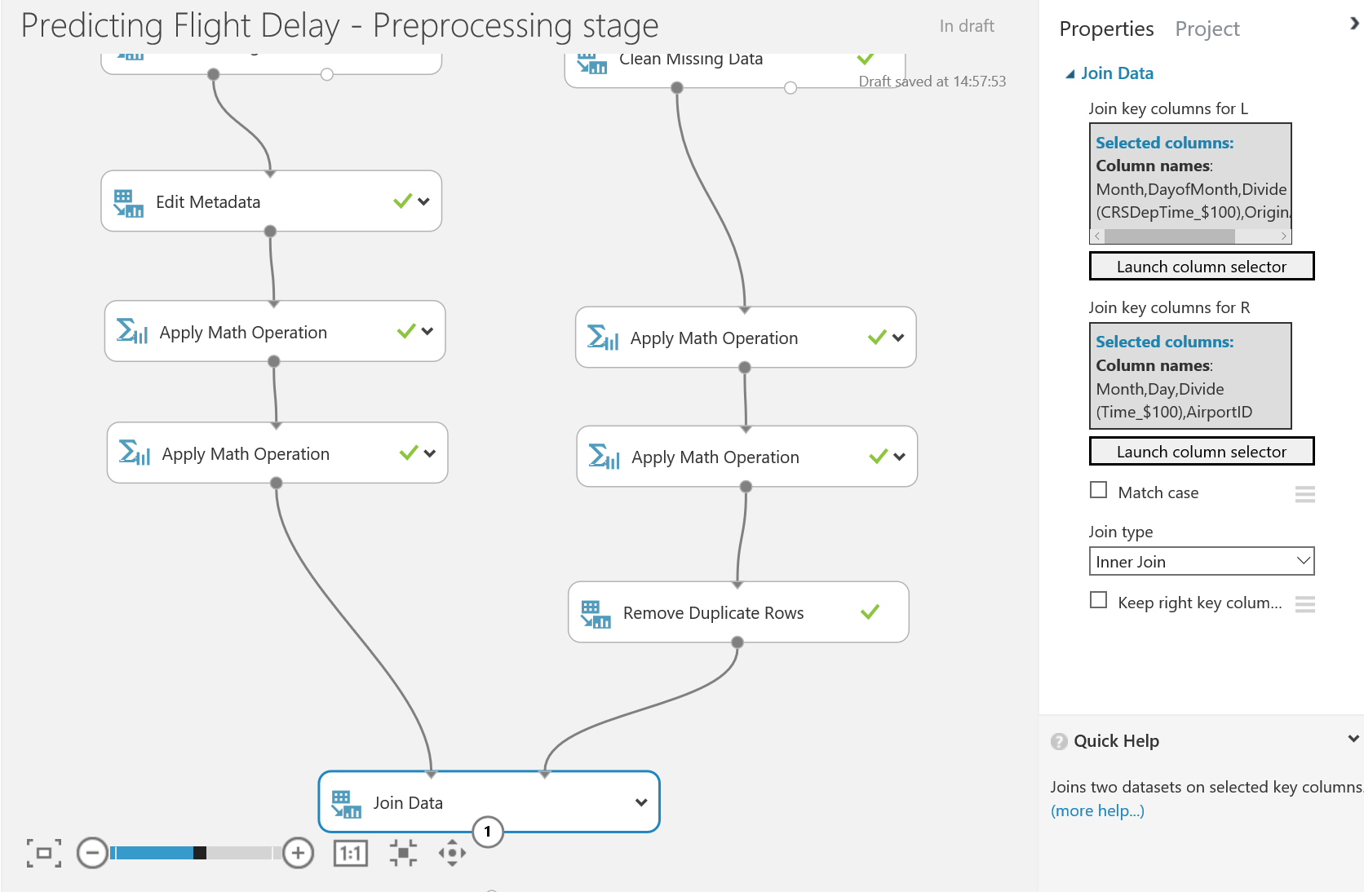

* The columns selected from the Flight Delay Data are Month, DayOfMonth, Divide(CSRDepTime_$100), OriginAirportID
  + **\*NOTE:\*** make sure “Allow duplicates and preserver column order” is Ticked
* The columns selected from the Weather Data are Month, Day, Divide(Time_$100), AirportID
* We are not matching on case and the Join Type is Inner Join

The results of joining the datasets is shown below and now we have manipulated the data into a clean format and will be able to input this data as training data into a model to learn.

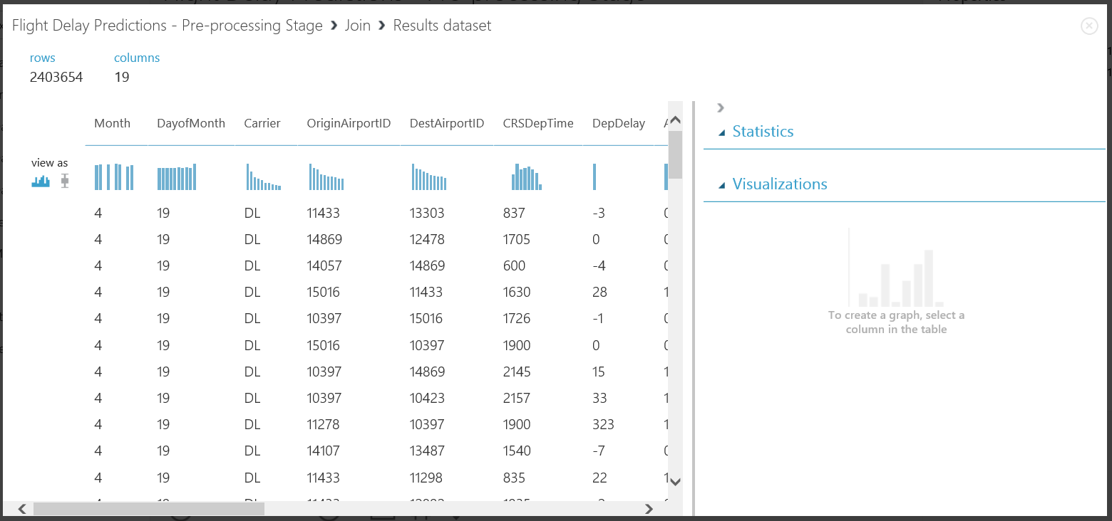

After joining the data above, we find we have many forms of the time column all in one dataset. We should remove these redundant columns before training our data to save time and processing cost.

Drag a ‘Select Columns in Dataset’ module onto the workspace and choose the following properties listed below in the ‘Launch Column Selector’ functionality:

‘All Columns’ -> ‘Exclude’ -> ‘CSRDepTime’ ‘Time’ and ‘TimeZone’

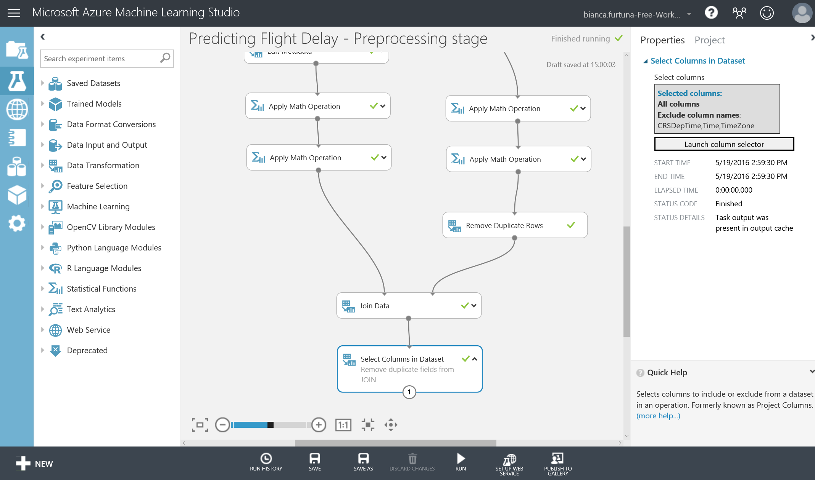

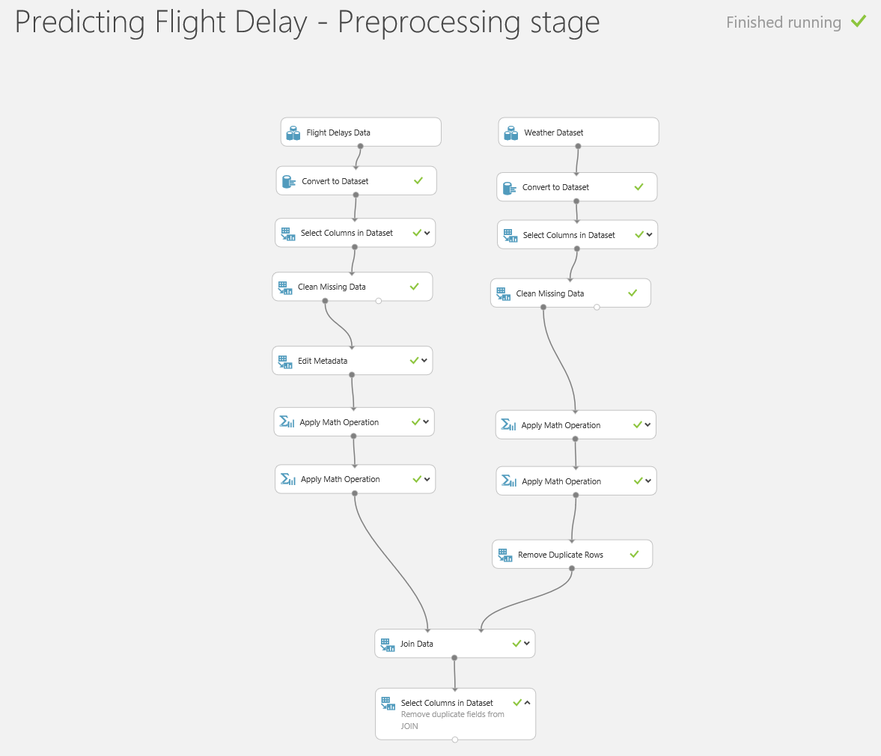

Run the experiment one more time before proceeding to the next section.

# Optional Lab: Python Jupyter Notebooks

Our experiment seems to be quite accurate, but we should be clear on why this so we are clear that the correlations used by the model make sense in business. We saw at the start of this lab that we can get basic statistics just by visualising the data and there are statistical modules to do this. However, we might wish to bring our own tools to bear and a great way for those with Python or R skills to do this is with Jupyter notebooks. These are ad hoc scripts which we can attach to our experiments or use on their own.

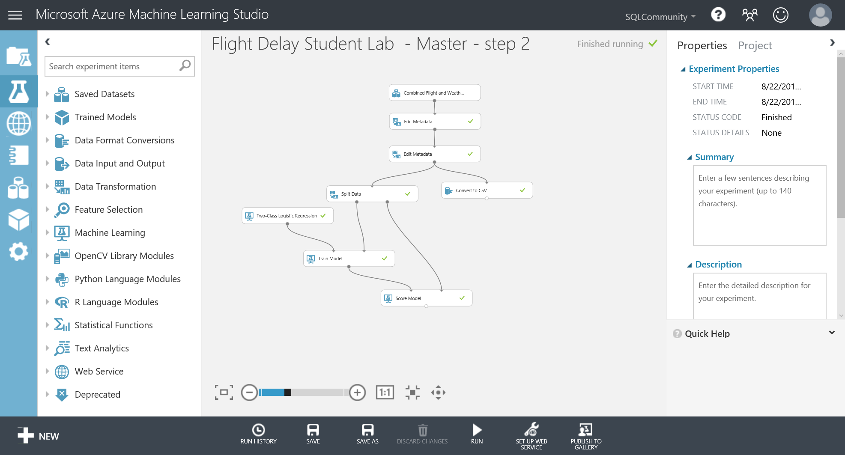To use these notebooks, we need to extract the data to a format (.csv) that the notebooks can use and this can quickly be done with the export to CSV module which we’ll connect to the output of the second metadata module:

Right click on the Export to CSV module and click Run Selected to just run that module.

When it’s finished right click again and select Open in a New Notebook -> Python 2:

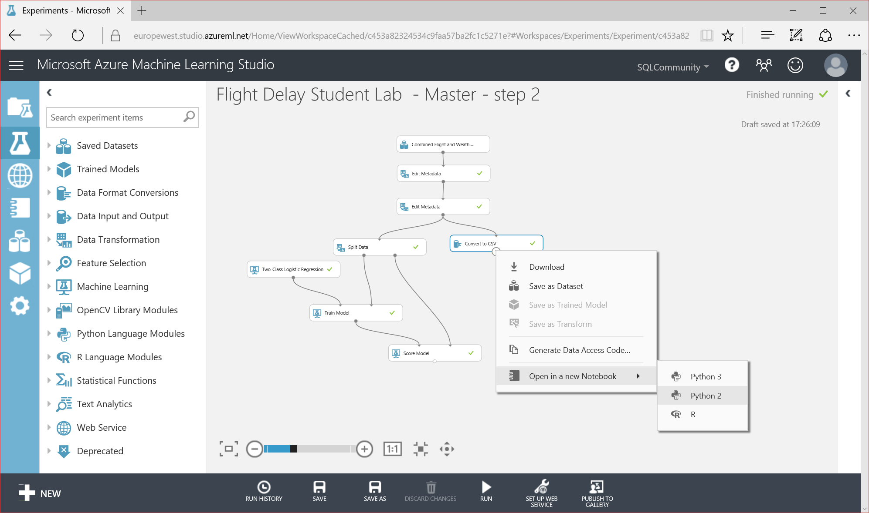

We’ll now be taken to a new browser window with our Notebook in:

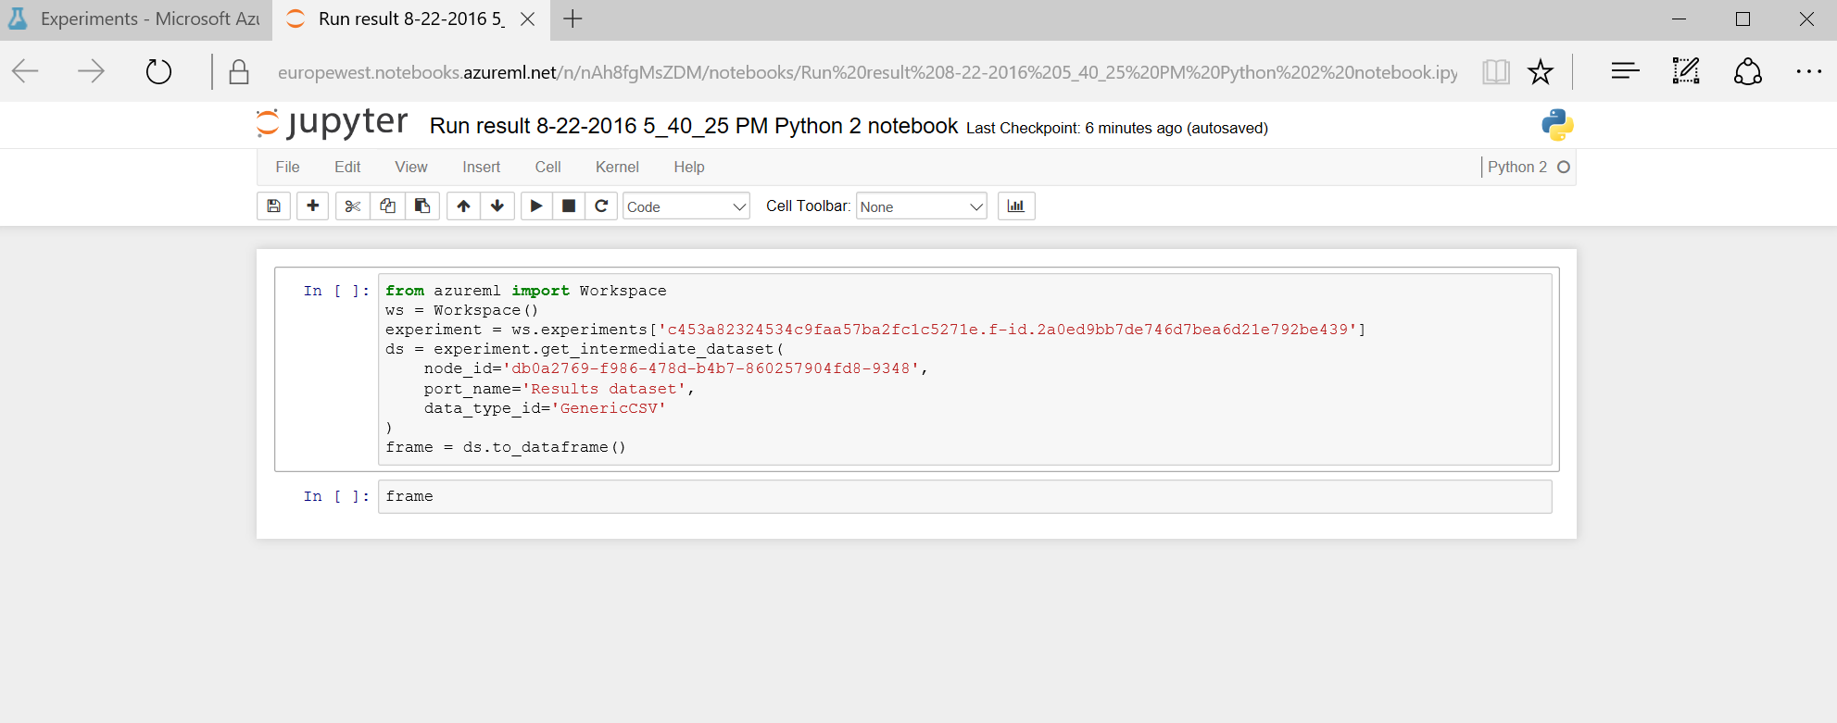

Notice we already have a stub script in it which takes our data and loads it into a dataframe called frame. The first thing we should do is rename our notebook to something meaningful as this notebook will persist in our ML workspace. So rename it click on save and confirm this by going back to the browser tab for ML studio and clicking on the Notebook icon on the left (it’s not yet renamed in the screenshot below):

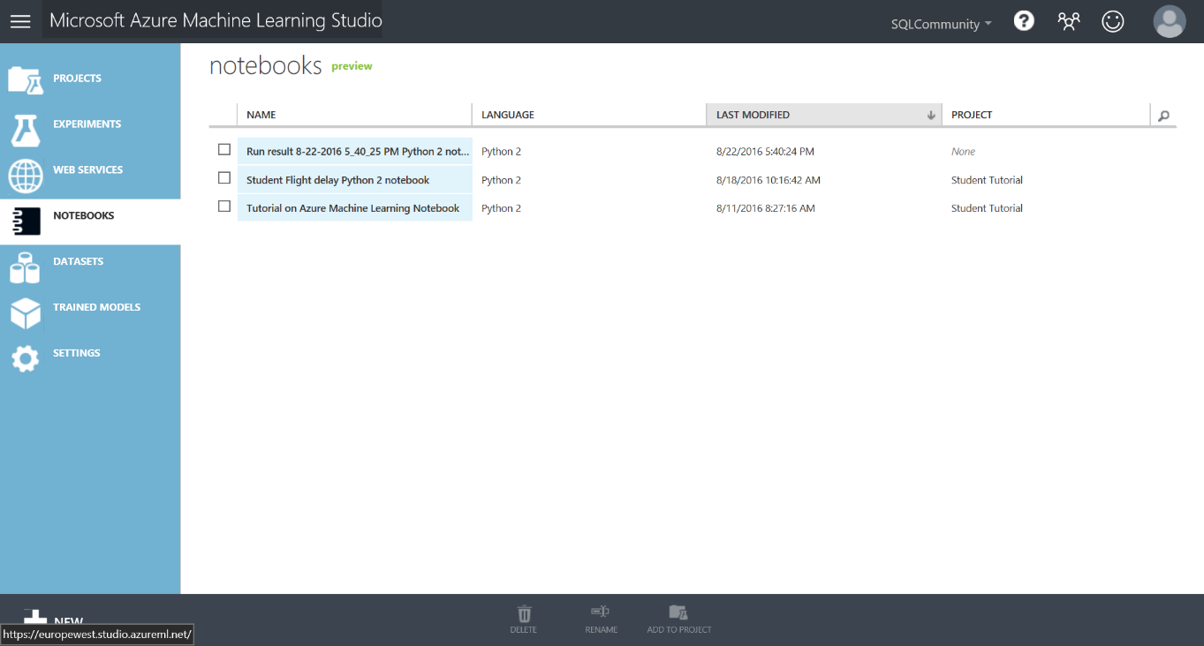

We can now go back to the Notebook tab and add some of our own code. Firstly, we need to run the cell with the existing code in to load the dataframe with data from our experiment which we do by setting focus on the cell and clicking on the run icon in the top toolbar.

In the second cell there is just the word frame and if we want to see a sample of our data we should change this to

print frame

and click the run icon to get back a sample of our data:

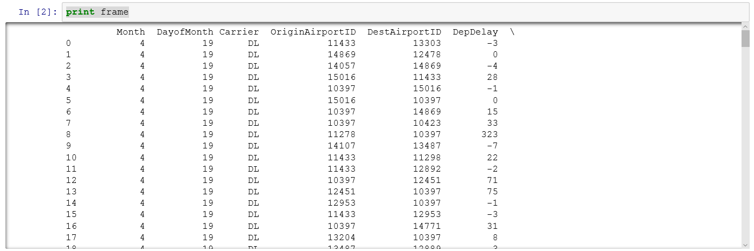

What we can do now is use any of the many libraries and function in Python to analyse this data without any further effort. In this case let’s see how the various features correlate with each other. This plot only works against numerical data to which statistics can be applied so we’ll need to exclude the carrier and use a separate data frame for this.

Create a new cell in the notebook and enter this code

correlationFrame = frame.drop("Carrier", axis=1)

print correlationFrame

and run this.

We can then use this to do our correlation plot but before we do we’ll need to bring in some libraries, so add a new cell and enter this:

import pip

import pandas

import numpy as np

import pandas as pd

import matplotlib

matplotlib.use("agg")

import matplotlib.pyplot as plt

#Now we have these libraries we can create the plot itself:

cm=correlationFrame.corr()

fig=plt.figure()

plt.imshow(cm,interpolation='nearest')

plt.xticks(list(range(0,len(cm.columns))),list(cm.columns.values), rotation=90)

plt.yticks(list(range(0,len(cm.columns))),list(cm.columns.values))

plt.colorbar()

If we run this now we’ll get a plot like this:

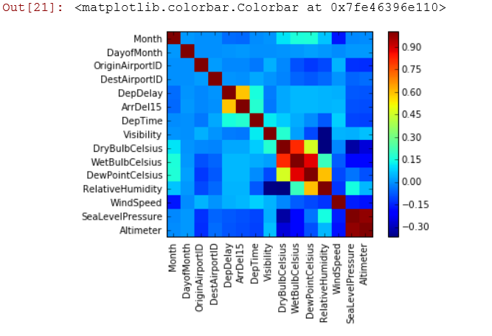

What this is showing us is how the various columns in our dataset are correlated. Some of this is obvious:

* The correlation on the leading diagonal is always one because month is perfectly correlated to month
* There is little correlation between month and the various temperature readings.

What we are interested is how each of these columns correlates with ArrDel 15 (the yellow box) and here we can see there is a strong correlation (about 0.65) with DepDelay. This makes sense - if a plane takes off late there is more chance it will land late. There is also some negative correlation with Altimete and see level pressure which may require further investigation.

This analysis can then be used to refine our experiment for example

* What does the RoC curve look like if we remove the DepDelay feature from our experiment?
* Can we predict Dep Delay and then feed that answer into this experiment?

There is no right answer to these so in machine learning we constantly iterate to success.

# Optional Lab: R Jupyter Notebooks

Our experiment seems to be quite accurate, but we should be clear on why this so we are clear that the correlations used by the model make sense in business. We saw at the start of this lab that we can get basic statistics just by visualising the data and there are statistical modules to do this. However, we might wish to bring our own tools to bear and a great way for those with Python or R skills to do this is with Jupyter notebooks. These are ad hoc scripts which we can attach to our experiments or use on their own.

To use these notebooks, we need to extract the data to a format (.csv) that the notebooks can use and this can quickly be done with the export to CSV module which we’ll connect to the output of the second metadata module:

Right click on the Export to CSV module and click Run Selected to just run that module.

When it’s finished right click again and select Open in a New Notebook -> R:



We’ll now be taken to a new browser window with our Notebook in:

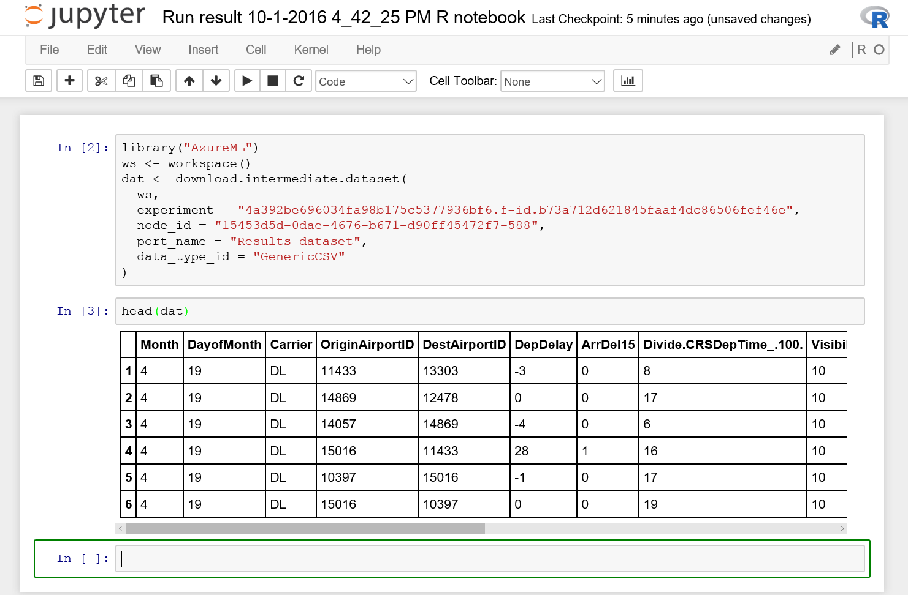

Notice we already have a stub script in it which takes our data and loads it into an R dataframe called dat. The first thing we should do is rename our notebook to something meaningful as this notebook will persist in our ML workspace. So rename it click on save and confirm this by going back to the browser tab for ML studio and clicking on the Notebook icon on the left (it’s not yet renamed in the screenshot below):



We can now go back to the Notebook tab and add some of our own code. Firstly, we need to run the cell with the existing code in to load the dataframe with data from our experiment which we do by setting focus on the cell and clicking on the run icon in the top toolbar. ( this has already been done in the Jupyter screenshot above).

In the second cell there is just the head(dat) which is what gave us the sample data in the first screenshot. Now we have this data in our Notebook we can leverage any of the 8,00+ libraries in R to analyse and plot this data. In this simple example we’ll try and understand the relationships between the numeric fields in the data using a correlation plot. Before we do that we need to eliminate the categorical variables in the data e.g. the airport IDs and the Carrier as these cannot be analysed in this way.

Add a new cell to the Notebook with the  icon and enter

CorrelationData <- dat

CorrelationData$Carrier <-NULL

CorrelationData$OriginAirportID <-NULL

CorrelationData$DestAirportID <-NULL

head(CorreladtionData)

Now we can add the code we need for the plot, and see how simple it is to plot a complex problem like this using one of the libraries in R. Firstly we need to calculate the correlation using the Cor function in R and then reshape the data into the right from for it to be plotted.

Add another new cell at the end of the Notebook with the  icon and enter the

library(reshape2)

CorrelationMatrix <- cor(CorrelationData)

MeltedMatrix <- melt(CorrelationMatrix)

head(MeltedMatrix)

To do the actual plot we’ll use the really well known ggplot library. This allows for all kinds of plotting and also allows plots to be built up in layers.

Add another new cell at the end of the Notebook with the  icon and enter the

library(ggplot2)

ggplot(data = MeltedMatrix, aes(Var2, Var1, fill = value))+

geom_tile(color = "white")+

scale_fill_gradient2(low = "blue", high = "red", mid = "white",

midpoint = 0, limit = c(-1,1), space = "Lab") +

theme_minimal()+

theme(axis.text.x = element_text(angle = 90, vjust = 1,

size = 12, hjust = 1))+

coord_fixed()

Run the cell and you’ll get a plot like this..

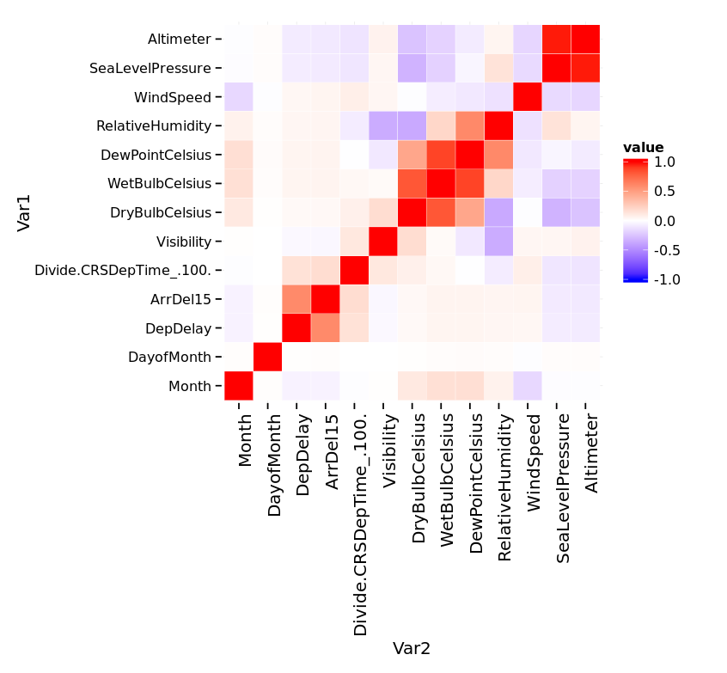

What this is showing us is how the various columns in our dataset are correlated. Some of this is obvious:

* The correlation on the leading diagonal is always one because month is perfectly correlated to month
* There is little correlation between month and the various temperature readings.

What we are interested is how each of these columns correlates with ArrDel 15 (the yellow box) and here we can see there is a strong correlation (about 0.65) with DepDelay. This makes sense - if a plane takes off late there is more chance it will land late. There is also some negative correlation with Altimete and see level pressure which may require further investigation.

This analysis can then be used to refine our experiment for example

* What does the RoC curve look like if we remove the DepDelay feature from our experiment?
* Can we predict Dep Delay and then feed that answer into this experiment?

There is no right answer to these so in machine learning we constantly iterate to success.

# Optional Lab: Python Modules

Azure ML allows us to add custom code in Python R as part of an experiment. In this simple exercise we’ll emulate the evaluate model module by using a Python script.

First we need to drag a Python module onto the design surface:

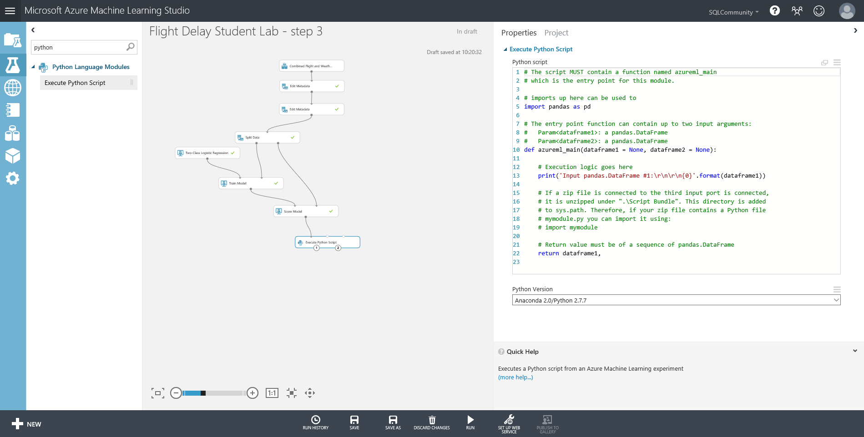

The Python module already has stub code in it load the data we are working on into dataframe1. We are going to plot a curve the [Receiver Operator Characteristic Curve](https://en.wikipedia.org/wiki/Receiver_operating_characteristic) (RoC)to get an idea of how our model is performing by replacing the sample code in the module with this script:

import matplotlib

matplotlib.use("TkAgg")

def azureml_main(dataframe1 = None):

import sklearn.metrics as m

import matplotlib.pyplot as plt

dataframe1 = dataframe1.dropna()

# pick the label out of the dataframe and the positive label

r1 = m.roc_curve(dataframe1["ArrDel15"], dataframe1["Scored Probabilities"], pos_label= 1)

plt.plot(r1[0], r1[1], 'r-', label="Boosted Trees");

plt.grid("on");

plt.legend(loc="best")

plt.savefig("roc.png")

return dataframe1,

To check this is working we can simply right click on the Python module and click run selected.

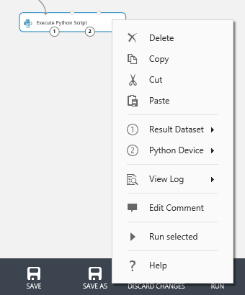

Once it has completed we can see the RoC curve by right clicking on output 2 (the one on the right) of the module: and click visualize

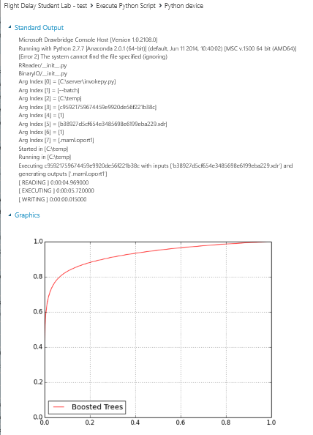

However, while the shape of this curve and the area under it are good indicators of accuracy if we want a numerical analysis of how well the model is working then we need a confusion matrix to show the

True positives, True negatives etc. and the standard scores that accompany these statistics:

* **Accuracy** = true Positives + True negatives over the overall total = 0.922
* **Recall** = true positives divided by true positives + false negatives = 0.684
* **Precision** = true positives divided by true positives + false positives = 0.913
* **F1 score** = .2 * (precision* recall)/ (precision + recall) = 0.782

We can add some more code to our python module to derive this information using the [scikit-learn](http://scikit-learn.org/stable/) library in Python. If we substitute all of this code in the Python module we’ll retain the plot we just created as well as these new measures:

import matplotlib

matplotlib.use("TkAgg")

import sklearn.metrics as m

import matplotlib.pyplot as plt

import pandas as pd

from sklearn.metrics import confusion_matrix as cm

def azureml_main(dataframe1 = None):

dataframe1 = dataframe1.dropna()

# pick the label out of the dataframe and the positive label and plot the RoC curve

r1 = m.roc_curve(dataframe1["ArrDel15"], dataframe1["Scored Probabilities"], pos_label= 1)

plt.plot(r1[0], r1[1], 'r-', label="Boosted Trees");

plt.grid("on");

plt.legend(loc="best")

plt.savefig("roc.png")

#Derive test statistics to show the accuracy of the model and output on POrt1

cmarray = cm(dataframe1['ArrDel15'], dataframe1['Scored Labels'])

TrueNeg, FalsePos = cmarray[0]

FalseNeg, TruePos = cmarray[1]

TruePos = float(TruePos)

FalseNeg = float(FalseNeg)

FalsePos= float(FalsePos)

TrueNeg= float(TrueNeg)

Accuracy = (TruePos + TrueNeg) /(TruePos+ TrueNeg + FalsePos + FalseNeg)

Recall = TruePos /(TruePos + FalseNeg)

Precision = TruePos /(TruePos+ FalsePos)

F1Score = 2 * (Precision * Recall)/(Precision + Recall)

data = {'Description': ['True Positives','False Negatives','False Positives','True Negatives','Accuracy','Precision','Recall','F1 Score'],'Score': [TruePos,FalseNeg,FalsePos,TrueNeg,Accuracy,Precision,Recall,F1Score]}

dataframe1 =pd.DataFrame(data,columns=['Description','Score'])

return dataframe1,

If we just rerun this module again we can see these new statistics by right clicking on output 1 (the left one) and selecting visualise again:

